CoNym Technical Documentation

Part I — System Overview

Overview
This document describes the software components developed by the University of Applied Sciences and Arts Northwestern Switzerland (FHNW) within a joint research project focused on behavioural authentication using artificial intelligence. The project explores privacy-preserving mechanisms for identity verification in cross-border mobility networks, but the underlying concepts are applicable to other domains that require decentralized or privacy-sensitive authentication.
The documentation focuses exclusively on the software developed by FHNW — namely CoNym, CoCoA, and Proacc — and their integration with external components. Other software developed by project partners, such as the AI-based behavioural authentication infrastructure from the Karlsruhe University of Applied Sciences (HKA) and mobility services from industrial partners, are described only to the extent required for context and interface understanding.

Project Context
The overarching goal of the project is to demonstrate that behavioural authentication — based on user interaction and device characteristics — can be performed in a privacy-preserving and federated manner. In the mobility domain, this enables users to authenticate seamlessly across service providers and national borders without sharing personally identifiable data.
To achieve this, HKA developed the Continuous Authentication (CA) infrastructure responsible for collecting, encrypting, and processing behavioural data. FHNW designed and implemented the complementary identity and access management stack, which integrates behavioural signals into standard authentication workflows compliant with OAuth 2.0 and OpenID Connect.

System Overview
The complete system consists of several interacting subsystems:
- CA Infrastructure (HKA):
  - The CA-Client, installed on user devices, collects behavioural data and performs local preprocessing and encryption.
  - The CA-Server performs encrypted inference on the behavioural data and forwards aggregated results to the FHNW subsystem.
- Identity & Access Integration (FHNW):
  - CoNym:
Central authentication and authorization server implementing OAuth 2.0 and OpenID Connect.
Based on the Janssen server, CoNym introduces support for behavioural authentication, device-bound identities, and pseudonymization features.
  - CoCoA:
Behavioural data aggregation service that receives input from the CA-Server, applies decay and lifetime management, and provides CoNym with behavioural confidence scores used during authentication.
  - Proacc:
Proxy access component that mediates between CoNym and external identity or service providers.
It validates CoNym tokens and performs OAuth Token Exchange operations (RFC 8693) against third-party identity providers to obtain usable access tokens for downstream services.
Together, these components enable the integration of behavioural authentication into existing OAuth/OIDC-based ecosystems while maintaining privacy and interoperability.

Deployment Model
FHNW components (CoNym, CoCoA, Proacc, Postfix, nginx) are containerised and deployed via Docker Compose for development and testing (e.g., on Switch Engines).
For a production-grade setup, a migration to Helm/Kubernetes and hardening of operational aspects (e.g., secrets management, networking, Postfix integration) is required.
Detailed deployment guidance is provided in a separate installation and configuration guide located in the opensource repository.

Relation to Other Project Components
The FHNW layer interacts with:
- Clients (e.g., mobile apps, web frontends) that authenticate via CoNym/Proacc using OAuth/OIDC.
- The CA-Server (HKA), which pushes behavioural results to CoCoA via REST over mTLS through the external ingress.
- External Identity Providers and services, which integrate through standard OAuth/OIDC flows or via Proacc using Token Exchange to obtain provider-native access tokens.

Use-Case
The system is designed to enable secure and privacy-preserving authentication across multiple service providers and jurisdictions.
Its primary objective is to extend the established OAuth 2.0 and OpenID Connect standards with behavioural and device-based authentication mechanisms, while preserving interoperability between existing identity providers (IdPs).
The following subsections describe the core use cases addressed by the system.

Cross-Provider Authentication
In conventional mobility networks, users often interact with separate applications and identity systems for each regional service provider. Each provider maintains its own user directory and login process, resulting in redundant user management and fragmented authentication experiences.
Using CoNym as an intermediary identity and access integration layer, different mobility providers can federate their identity systems.
Possible configurations include:
- A single CoNym instance shared among all providers, which manages authentication and translates tokens for multiple IdPs.
- Separate CoNym instances operated by individual providers, configured to route authentication requests between each other.
This enables users to authenticate once with their home provider and seamlessly access services offered by other providers. The approach reduces login friction, simplifies service integration, and allows each provider to maintain control over its own identity management infrastructure.

Cross-Border and Pseudonymous Identity Federation
In cross-border scenarios, personal data protection requirements differ between jurisdictions.
CoNym’s pseudonymization layer allows service providers to exchange identity assertions without disclosing personally identifiable information.
For example, a user’s email address can be replaced by a pseudonym while maintaining functional communication through the email proxy (Postfix).
This ensures that authentication and service access can operate across national boundaries without violating data locality or privacy rules.
When multiple CoNym instances participate in such a federation, pseudonymized attributes can be propagated consistently between them, ensuring that users remain linkable across borders only through pseudonymous identifiers.

Continuous and Behavioural Reauthentication
Traditional authentication mechanisms rely on credentials or tokens with relatively long validity periods. In contrast, the presented system introduces Continuous Authentication (CA) as an additional security and usability layer.
The CA-Client on the user device continuously collects behavioural signals. The CA-Server evaluates these signals and transmits behavioural confidence scores to CoCoA, which aggregates and maintains these over time.
When an access token expires, the user can be reauthenticated automatically if the behavioural score for the device remains above a configurable threshold.
If the score is too low, CoNym falls back to a standard credential-based login flow.
This mechanism enables seamless, passwordless reauthentication without sacrificing security. It also allows for fast re-entry after temporary inactivity and provides the basis for session invalidation in case of anomalous behaviour (e.g., device theft), although the latter was not a primary focus of the current implementation.

Summary of Main Use Cases
Use Case | Primary Actors | Description | Benefits
Cross-Provider Authentication | User, Service Provider, CoNym | Single login across multiple mobility apps using CoNym federation | Unified access, simplified onboarding
Cross-Border Pseudonymous Federation | User, CoNym, External IdPs | Privacy-preserving authentication between national systems | Data minimization, compliance
Continuous Reauthentication | User, CoNym, CoCoA, CA-Server | Behavioural authentication for seamless relogin | Security, convenience, dynamic session trust

System Context
The project integrates two collaborating domains:
- Continuous Authentication (HKA) providing privacy-preserving behavioural authentication, and
- Identity & Access Integration (FHNW) incorporating behavioural signals into standard OAuth 2.0 / OpenID Connect flows and token exchange.
While this work was validated with mobility services, the approach is generalizable beyond the mobility sector to any ecosystem where multiple service providers (and IdPs) need privacy-preserving, interoperable authentication and seamless reauthentication.

System Boundaries and Responsibilities
Domain / Partner | Primary Responsibilities
FHNW (Identity & Access Integration) | Integrate CA signals into OAuth/OIDC; pseudonymisation; token exchange–based federation with external IdPs/services.
HKA (Continuous Authentication) | Privacy-preserving behavioural analysis and delivery of behavioural status to the FHNW layer.
External Mobility/Service Providers & IdPs | Provide services and/or issue identity assertions; integrate via OAuth/OIDC or token exchange.
End-User / Client | Uses client application(s) that authenticate via the FHNW layer; benefits from seamless behavioural reauthentication.

External Actors and Interfaces
Actor | Description | Interactions
End User / Client Device | Runs the CA-Client and mobility app; interacts with CoNym for login, token renewal, and service access. | Communicates with CoNym and Proacc
CA-Server (HKA) | Receives encrypted behavioural data from clients, performs encrypted inference, and sends aggregated results to CoCoA. | Pushes behavioural metrics to CoCoA
External Identity Providers (IdPs) | Provide user credentials and identity assertions in standard OAuth/OIDC flows. | Integrated with CoNym and Proacc using OAuth standards
Mobility / Service Providers | Consume access tokens to deliver services such as booking or ticketing. | Receive access tokens issued by CoNym or exchanged by Proacc.
Email Infrastructure | Used for pseudonymous email proxying. | Postfix interacts with CoNym for resolution

System Context Diagram
Focused on the context around the FHNW part only; no subcomponents shown.

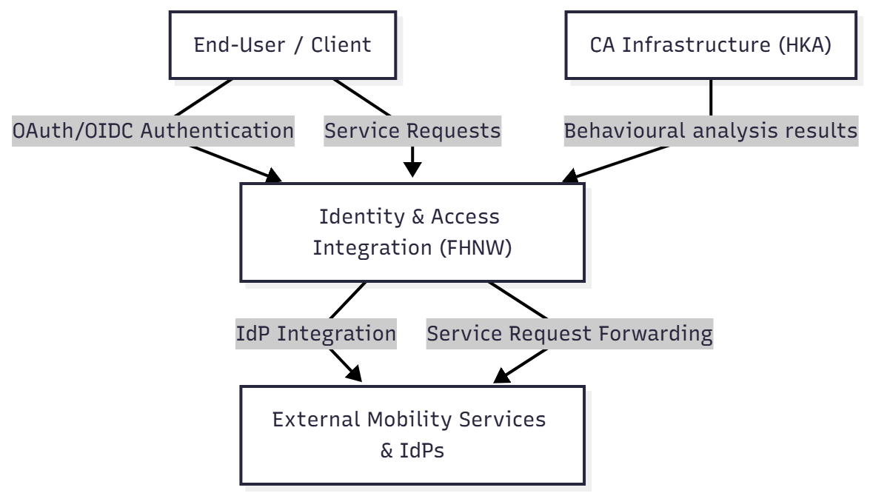

Integration Scenarios

Multi-Provider Federation
In the intended multi-provider setup, several CoNym instances (operated by different providers) may federate through routing and token exchange. Each provider retains its own identity management but can trust tokens issued by another CoNym instance.
This enables seamless user mobility between providers and countries.

Single-Provider Demonstrator (Field Test)
The field test represented a simplified single-provider configuration:
- One CoNym instance integrated with a single IdP and service backend.
- One mobile application (Raumobile) as client.
- Behavioural reauthentication via CA system verified end-to-end.
This configuration validated technical interoperability and behavioural authentication workflows but did not include multi-CoNym federation or cross-border routing.

Summary
The system context defines a collaborative environment where:
- HKA provides privacy-preserving behavioural data processing.
- FHNW provides federated identity and access integration with behavioural authentication.
- Industry partners provide real-world service and client infrastructure for integration and validation.
The next chapter (Architecture) will detail the internal structure of the FHNW subsystem and describe data flows, APIs, and deployment topology in greater depth.

Part II — System Design & Architecture
(From here downwards is just empty chapeters and notes, no real content yet)

Architecture & Components

Architectural Overview
This section describes the architecture of the Identity & Access Integration layer developed by FHNW. It provides an overview of its main components, their responsibilities, and their interactions with the Continuous Authentication (CA) infrastructure from HKA and external identity and service providers.

Architectural Summary
The FHNW system extends standard OAuth 2.0 / OpenID Connect (OIDC) identity management with privacy-preserving pseudonymization and behavioural authentication features. It is designed as a container-based system that can integrate seamlessly into federated and cross-border identity ecosystems.
All major services are deployed as separate containers in a single Docker Compose environment. The boundary of the FHNW subsystem is defined by an nginx container, which terminates all TLS / mTLS connections and routes requests to internal services via secure channels.

Main Components
Component | Description | Technology / Stack
CoNym | Central OAuth 2.0 / OIDC server based on Janssen 1.9.0. Extended with behavioural authentication (via authorization-challenge endpoint) and pseudonymized claim handling. | Janssen 1.9.0 (Java 17), MySQL 8.0.30
CoCoA | Receives and aggregates behavioural data from the CA-Server. Provides CoNym with confidence values (distances to baseline behaviour). | Spring Boot 3.2.4 (Java 21), MariaDB 11
Proacc | Request proxy. Validates CoNym tokens of incoming requests and exchanges them for tokens from the responsible IdP before forwarding the request. | Jetty 12.0.22 (Java 21)
Postfix | Pseudonymous email relay. Performs lookup and reverse resolution of e-mail pseudonyms. | Postfix 3.6.4 + Python 3 transport scripts
nginx | Edge proxy terminating TLS / mTLS and routing requests to internal components. | nginx 1.25.4
Auxiliary utilities:
- Janssen Configurer – Java program that automatically deploys CoNym’s configuration and scripts during startup or as hot patches.
- CoNym Client – Command-line Java application used to test CoNym, Proacc, and CoCoA without requiring a mobile client.
- Certbot – Manages certificate acquisition and renewal (Let’s Encrypt).

Component Interactions
Source | Target | Protocol / Security | Purpose
CA-Server (HKA) | nginx → CoCoA | REST API over mTLS | Push behavioural data (distance values representing deviation from user baseline).
CoNym | CoCoA | Internal REST (no TLS, isolated network) | Pull aggregated behavioural status when performing behavioural authentication.
Clients (Apps) | nginx → CoNym | OAuth 2.0 / OIDC over TLS or mTLS | Authenticate users, obtain and refresh tokens, access behavioural login.
Clients (Apps) | nginx → Proacc | HTTP over TLS with OAuth 2.0 access token | Make request to Services requiring Authorization.
Proacc | CoNym | OAuth 2.0 / OIDC over TLS | Validate tokens on behalf of external clients.
Proacc | External IdP | OAuth 2.0 Token Exchange (RFC 8693) | Exchange CoNym tokens for provider-native tokens.
(optional) External IdPs | nginx → CoNym | Standard OAuth 2.0 call (token introspection or public-key validation) | Only if configured to validate CoNym tokens dynamically.
Postfix | CoNym DB | Direct DB access (internal) | Lookup and reverse pseudonymous email addresses.
All connections between external components and nginx are TLS-terminated at the edge. Internal traffic between containers is restricted to the internal Docker network.
No custom APIs are exposed beyond the defined OAuth/OIDC and REST interfaces.

Persistence Model
Each component maintains its own database instance for isolation and maintainability.

CoNym (MySQL 8.0.30)
- Managed by Janssen for all standard OAuth/OIDC data (users, sessions, tokens, clients, scopes).
- Custom tables:
  - Claims Table: Maps original user claims (e.g., email) to pseudonyms per client and claim type.
  - UserAuthentication Table: Stores user-device associations and metadata for behavioural authentication.
  - Cleanup Tables: Manage expiration for temporary proxy users and pseudonym entries.

CoCoA (MariaDB 11)
- Stores pseudonym device identifiers and associated timestamped behavioural results for different behavioural data sources.
- Data decays over time; expired entries are deleted.
- Aggregations are computed on demand for CoNym’s behavioural authentication requests and are not stored in a data table.
- A log tables stores recent events like pushed behavioural results or requested aggregation results for a short period of time, intended for testing and diagnostics by HKA.

Layered Architecture Diagram
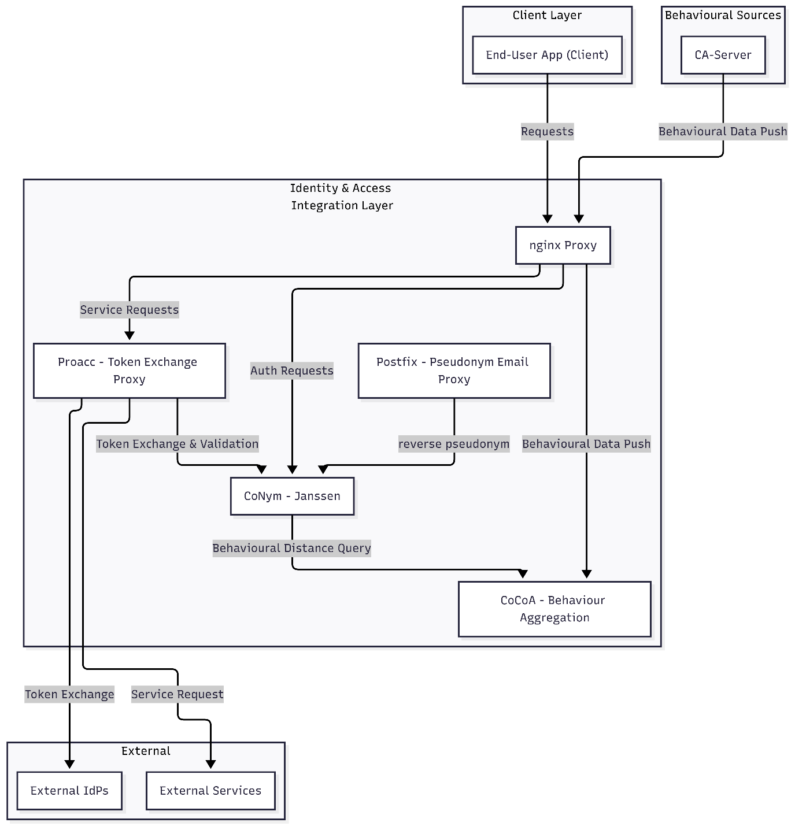

Architectural Characteristics
- Standards-based Integration:
Fully compliant with OAuth 2.0, OpenID Connect, OAuth Token Exchange (RFC 8693), and OAuth 2.0 for First-Party Applications (used for behavioural authentication via the authorization-challenge endpoint).
- Loose Coupling:
Each major service operates independently with clearly defined REST or OAuth-based interfaces. Failures in optional components (e.g., Proacc, Postfix) do not interrupt the core authentication workflow.
- Security:
All external communication uses TLS or mTLS.
Behavioural data exchange between CA-Server and CoCoA is strictly mTLS-secured.
Internal communication occurs within an isolated network namespace.
- Extensibility:
CoNym extends Janssen through custom scripts written in Java or Python (“interception scripts”) and shared libraries.
The architecture allows new pseudonym or proxy mechanisms (e.g., SMS gateways) to be integrated analogously to Postfix.
- Deployability:
Distributed via Docker Compose for development and research deployment.
Production hardening and orchestration (e.g., by industrial partners) would require configuration management, secret rotation, and monitoring extensions.

Components

CoNym
CoNym is the central identity and authentication server of the FHNW subsystem.
It extends the Janssen 1.9.0 platform to support behavioural authentication and privacy-preserving pseudonymization.
CoNym can operate both as a standalone Identity Provider (IdP) and as a proxy to other IdPs, providing a uniform authentication layer across organizational and national boundaries. Its architecture remains standards-compliant with OAuth 2.0 and OIDC, enabling transparent and easy integration into existing ecosystems.

Functional Responsibilities
Function | Description
User and Token Management | Inherits all standard OAuth 2.0 and OIDC functionality from Janssen, like implicit, and hybrid authentication flows.
Device Authentication and Binding | Authenticates devices either via mutual TLS (mTLS) or device credentials (ID + secret) and associates them with user accounts during the first successful credential-based login. This binding is a prerequisite for behavioural authentication.
Behavioural Authentication | Provides behavioural authentication build on top of the OAuth 2.0 authorization-challenge mechanism, extended with behavioural evaluation logic.
Pseudonymized Claim Handling | Replaces, hides, or omits sensitive claims in ID tokens, access tokens, and the user-info endpoint response according to configurable privacy rules.
Delegated Authentication (Proxy Mode) | Forwards credential-based authentication requests to third-party IdPs, creating and maintaining corresponding local proxy users.
User Management (Local Mode) | Manages local users and credentials when used as an independent IdP.
OAuth Token Exchange Integration | Participates in OAuth 2.0 Token Exchange operations, either validating tokens for local Proacc instances or acting as exchange target for remote Proacc instances in federated setups.

Behavioural Authentication
CoNym implements behavioural authentication by extending the OAuth 2.0 authorization-challenge process (RFC 9470 /draft standards).
The dedicated endpoint is provided at:
/jans-auth/restv1/authorize-challenge
and is automatically advertised via:
/.well-known/openid-configuration
This endpoint is implemented through a custom Janssen interception script, which performs the behavioural evaluation workflow. OAuth 2.0 identifies different authentication method over a so called acr (Authentication Context Class Reference) value. The behavioural authentication is available under the acr value behavioral_auth.
Conceptually a behavioural authentication follows the following steps:
- The client authenticates the device using either
  - mutual TLS, or
  - device credentials (device ID + secret) over TLS.
- The server identifies the device and queries CoCoA for the most recent behavioural distance value associated with that device.
- The returned numeric distance (0 = identical behaviour, 1 = fully dissimilar) is compared to a dynamic configurable threshold. Dynamic, as their is a default threshold that is tightened further, based on the requested scopes (access rights)
- If the distance is below the threshold, CoNym issues new access and ID tokens, for the user bound to the device, without requiring credential input.
- If the distance exceeds the threshold, the authentication fails.
(The client should fall back to a standard credential-based login)
The actual OAuth exchange may include additional request and response steps (e.g. authorization code issuing or PKCE and PAR related steps), but these are abstracted here for conceptual clarity.

Pseudonymization
Open ID Connect (OIDC) already allows to pseudonymize the subject identifier (sub) using a concept called pairwise subject identifiers. CoNym builds on this concept enabling pseudonymization for all user claims.
Each pseudonym is identified by the triplet: (userId, claimName, sectorId)
- sectorId groups multiple clients into the same privacy/security domain as defined by OIDC.
- Claims are pseudonymized, hidden, or passed in plain form depending on configuration (Unless pseudonymization is fully disabled).
- If the client (or its sectorId) matches that of the user’s originating IdP, plain claims are returned.
- Otherwise, claims are hidden or generated pseudonyms are returned (they may differ between sectors).
Pseudonymization configuration is defined per claim type and determines:
- The pseudonymization algorithm (deterministic or random).
- The derivation and encoding algorithms.
- Persistence and caching behaviour.
- Whether a claim is included, pseudonymized, or omitted entirely.
Reverse mapping of pseudonyms is accessible only internally and for persisted pseudonyms, used primarily by Postfix for pseudonymous email routing.

External Identity Providers
CoNym can act as both:
- Identity Provider (IdP) – managing users locally through its admin interface.
- OAuth 2.0 Client (Delegated Mode) – forwarding authentication to one or more external IdPs.
The delegation mode can be used by specifying the delegated_authentication acr value. Configuring it as default value unburdens the client from specifying it manually on each request.
In delegated mode:
- Credential-based login requests are relayed to the selected external IdP.
- Upon successful authentication, CoNym creates a local proxy user linked to that external account.
- Proxy users may be ephemeral and recreated as needed.
- Users or clients can choose the IdP to use when multiple are configured.
External IdPs may optionally validate CoNym-issued tokens using standard OAuth 2.0 introspection or JWT signature verification endpoints.
This functionality is fully standards-based and requires no custom APIs.

Security and Protocols
Purpose | Mechanism
Device Authentication | Mutual TLS or device credentials (device ID + secret)
User Authentication | Standard OAuth 2.0 and OIDC flows
Behavioural Authentication | Authorization Challenge endpoint (OAuth 2.0 for First-Party Applications)
Token Validation | OAuth 2.0 Introspection or JWT signature verification
Token Exchange | OAuth 2.0 Token Exchange (RFC 8693)
REST Interactions | JSON / HTTPS over TLS
Protocol Enhancements | PKCE and PAR supported for both regular and behavioural flows

Interaction with Other Components
Partner | Direction | Purpose | Security
CoCoA | Pull | Retrieve behavioural distance values for identified devices | Internal (secured network)
Proacc | Receive / Respond | Validates incoming tokens via the user-info endpoint; acts as target for token exchange from remote Proacc instances | TLS (internal network)
Postfix | DB access | Provide pseudonym mappings for pseudonymous email handling | Local DB connection
External IdPs | Bidirectional | Delegated authentication, optional token introspection | TLS
Clients (Apps) | Receive / Respond | Perform OAuth / OIDC login and behavioural reauthentication | TLS / mTLS

Persistence and Configuration
CoNym uses MySQL 8.0.30 as its database backend.
The database includes:
- All standard Janssen-managed OAuth 2.0 / OIDC tables (users, tokens, sessions, clients, scopes).
- Extended tables for:
  - Claims: mapping between user claims and pseudonyms.
  - User cleanup: managing expiration and regeneration of ephemeral proxy users.
System configuration is stored in files and applied automatically through the Janssen Configurer utility. Custom logic is implemented through interception scripts written in Java, supplemented by a custom shared Java library.

Summary
CoNym serves as the core identity and privacy component of the FHNW subsystem.
By combining standard OAuth 2.0 / OIDC mechanisms with configurable pseudonymization and behavioural authentication, it provides a flexible yet standards-compliant bridge between traditional identity systems and privacy-aware continuous authentication. Its modular design enables integration with other IdPs, proxies, and services without requiring extensive changes in client behaviour.

CoCoA
CoCoA (Collector of Continuous Authentication information) is the FHNW subsystem responsible for storing, decaying, and aggregating behavioural distance values produced by the CA-Server (implemented by HKA).
CoCoA’s role is limited yet essential:
- Accept behavioural distance values from CA-Server.
- Apply per-entry decay rules supplied by CA-Server.
- Aggregate values across behavioural sources.
- Provide a unified behavioural distance to CoNym during authentication.
Its design ensures privacy (short-lived ephemeral storage), and configurability for future extensions.

Functional Responsibilities
Function | Description
Behavioural Data Ingestion | Receives device-associated behavioural distances from the CA-Server over REST + mTLS. Data is cleartext at this point.
Decay Application | Applies a decay function to each stored entry based on the timestamp difference between generation and query time, using decay parameters supplied by the CA-Server for each entry.
Aggregation | Combines distance values originating from multiple behavioural sources using the median.
REST API for CoNym | Exposes an internal endpoint for CoNym to obtain a behavioural distance for a device, optionally restricted to a specific behavioural source.
Ephemeral Storage Management | Removes entries once they have fully decayed or exceed their retention lifetime.
Diagnostic Access | Provides a restricted diagnostic view (mTLS secured REST) for development and field test verification.
CoCoA performs no authentication beyond mTLS verification of the CA-Server. This is delegated to a reverse proxy (nginx), but CoCoA can be configured to handle this itself.

Behavioural Data Model
Before the CA-Server pushes behavioural entries for a device, it must first perform a pseudonym registration request.
This request supplies:
- pseudonym (device identifier)
- expiration date (defines how long the device is considered valid)
- history value (how many previous entries should be retained for inspection)
The history value affects only the diagnostic log, not behavioural aggregation.
For authentication purposes, CoCoA always uses the latest entry per authSource.
Each behavioural entry stored after registration consists of:
- Device Identifier (pseudonym):
A device ID deterministically derived from device credentials generated by the CA-Client. The credentials are shared between both the CA-Client and user application on the user’s device.
- Source Identifier (authSource):
Specifies the behavioural channel producing the distance (e.g. motion, keystrokes).
Enables aggregation across channels or source-specific queries.
- Distance Value (authDistance):
A float in the range:
  - 0.0 → identical behaviour
  - 1.0 → maximally different
- Timestamp (authTimestamp):
When the behavioural sample was generated on the device.
If omitted, CoCoA substitutes the ingestion time.
- Decay Parameters (decayTime, parameterA, parameterK):
Provided by the CA-Server for each entry.
CoCoA applies the configured decay function during lookups, not ingestion.
There is no behavioural metadata beyond the above fields.

API for CoNym
CoNym retrieves the behavioural distance for a device via an internal (shared internal docker compose network) REST call.

Lookup Semantics
Inputs:
- Device identifier (pseudonym - required)
- Source Identifier (authSource - optional):
  - If a specific source is provided → return the decayed distance from that source only.
  - If set to "" (empty) → return aggregated value across all decayed sources.
  - If omitted → return the distance for the default source.
Outputs:
- Numeric distance value already decayed and aggregated (if applicable).
- Or an error if no data is available for the requested parameters.

Ingestion from CA-Server
The CA-Server is the only external actor that sends data to CoCoA.
- Transport: REST over mTLS (client certificate required)
- Invocation: always initiated by the CA-Server
- Pseudonym Registration Request:
  - pseudonym (device identifier)
  - expiry
  - history
- Behavioural Entry Update Request:
  - pseudonym (device identifier)
  - authDistance
  - authTimestamp
  - authSource
  - decayTime, parameterA or parameterK
CoCoA does not validate the device identity itself — it only verifies the CA-Server via mTLS and trusts the provided data. Malformed entries are rejected, but no device-level authentication occurs.

Decay Model
CoCoA applies decay per entry using the parameters supplied by the CA-Server.
Decay is applied at lookup time, based on the difference in time between the query time and the authTimestamp.
Different behavioural sources may have different decay characteristics.
This allows future extensibility (e.g., different volatilities across channels).
For each entry a configuration parameter A or K must be provided. Depending on the provided parameter and it’s value a different decay behaviour is used. The function choices was made by the HKA team and is justified in their documentation.

Aggregation
Once all entries are decayed, CoCoA aggregates them into one number:
- Default strategy: median across all available sources.
- Source-specific requests: no aggregation; return only that source.

Persistence
CoCoA uses MariaDB 11 with three relevant areas:

Pseudonym Table
Stores registered device identifiers and their associated metadata:
- pseudonym
- expiration time
- history limit
- registration timestamp

Behavioural Entry Table
Stores behavioural distance results including:
- latest entry per authSource (used for aggregation)
- additional entries kept for debugging (up to the configured history limit)
Entries automatically expire or are purged when:
- the pseudonym expires,
- decay renders them irrelevant, or
- history limits are exceeded.

Diagnostic Log Table
Contains logs for diagnostic purposes accessible via the diagnostic REST view.

Technology Stack
- Runtime: Java 21
- Framework: Spring Boot 3.2.4
- Database: MariaDB 11
- Communication:
  - CA-Server → CoCoA: REST + mTLS
  - CoNym → CoCoA: internal REST (no mTLS; network isolation)
- Deployment: independent container in Docker Compose
- Diagnostics: REST browser view requiring installation of client certificate

Interaction with Other Components
Partner | Direction | Purpose | Security
CA-Server | Push | Registers pseudonyms and sends behavioural distances and decay parameters | REST + mTLS
CoNym | Pull | Retrieve decayed/aggregated behavioural distance for authentication | Internal REST
Diagnostic Tools | Read | Manual lookup of historic entries and logs | mTLS (browser certificate)
CoCoA does not interact with Postfix, Proacc, external IdPs, or clients.

Summary
CoCoA is a focused behavioural-data subsystem that stores, decays, and aggregates behavioural distance values supplied by the CA infrastructure.
It defines a clear separation of responsibilities: the CA-Server performs all behavioural inference, while CoCoA maintains short-lived behavioural evidence and returns aggregated distances to CoNym when needed for behavioural authentication.

Proacc
Proacc enables client applications to access external service providers through a single consistent entrypoint, independent of where the underlying services are hosted or which Identity Provider (IdP) they belong to. It performs routing, token validation, token exchange, and optional request rewriting before forwarding requests to the appropriate service.
While a service provider may choose to directly accept CoNym tokens, using Proacc provides two major advantages:
- Uniform Integration: Clients only need to talk to one endpoint, even in ecosystems with multiple IdPs or multiple CoNym instances.
- Compatibility Layer: Existing services need only implement standard OAuth 2.0 Token Exchange (RFC 8693) rather than adapt to CoNym directly.

Functional Responsibilities
Function | Description
Token Validation | Validates incoming CoNym tokens, typically via the user-info endpoint (which implicitly verifies the token).
Token Exchange | Exchanges the validated CoNym token for a service-native token at the service provider’s IdP.
Routing & Target Resolution | Determines which service to call and which IdP to contact — either implicitly (transparent mode) or explicitly (forwarding mode).
Request Forwarding | Acts as a reverse proxy: forwards client requests to service providers using the exchanged token.
Identifier / Claim Rewriting | Optionally rewrites identifiers inside URLs or headers (e.g., replacing a CoNym-internal user ID with the service provider’s local user ID).
Configurable Processing Pipeline | Each route defines a sequence of processing tasks (e.g., validate token, exchange token, rewrite path, add parameters).
Proacc performs no behavioural logic, no pseudonymization, and does not hold identity data. Its job is strictly to make CoNym-based authentication easier to integrate with existing services.

Routing Modes
Proacc supports two complementary routing approaches:
- 1. Transparent Routing Mode
Clients call URLs of the form: https://<ProaccHost>/<TransparentEndpoint>/<ServicePath>
Proacc then associates the transparent endpoint with a service provider host. And defines the initial forwarding target as: https://<ServiceHost>/<ServicePath>
This mode allows an existing client to simply switch the host and keep all paths identical — ideal for retrofitting existing apps.
- 2. Explicit Forwarding Mode
Clients call: https://<ProaccHost>/<ForwardEndpoint>?forwardUri=...&<extraParams>
This mode:
- explicitly defines the target service URI,
- allows additional routing metadata (useful in multi-hop scenarios)
Transparent and explicit routes share the same internal processing pipeline once the initial target has been resolved.

Processing Pipeline
Each configured route defines a sequence of tasks processed in order.
The current task types include (simplified, high-level):
- Validate Token
- Add Query Parameter
- Drop Token
- Exchange Token
- Rewrite Request
The pipeline is extensible, enabling new task types when necessary.

Token Handling
Proacc typically validates incoming tokens by retrieving user information from CoNym’s user-info endpoint, which also implicitly validates the token.
This avoids having to differentiate between JWT and non-JWT access tokens.
When forwarding to an external service provider, Proacc may (depending on configuration):
- Use the incoming CoNym token directly, or
- Exchange it for a target-native token via RFC 8693.
During token exchange, Proacc may request:
- Default scopes expected by the target provider,
- Adjusted scopes for privacy,
- Identifiers that the target expects (e.g., depseudonymised subject).
This allows existing services to operate without modification.

Request Flow
- 1. Client → Proacc
The client sends an API request with a CoNym-issued access token.
- 2. Target Resolution
Depending on the routing mode: The initial target Uri is constructed.
(Initial because the task pipeline can adapt it further)
- 3. Route Selection
Depending on the selected target URI a route is chosen
(Each route specifies a regex matcher, to declare its responsibilities)
- 4. Applying Transformation Pipeline
The tasks depend on the configuration of the selected route, but a common one may include the following two steps.
  - Token Validation
(Delegated to the IdP that issued the token, here CoNym)
  - Token Exchange
(Replaces the CoNym token with a service native token over RFC 8693)
- 6. Request: Proacc → Service Provider
The request is forwarded to the target service using the exchanged token.
- 7. Response: Service Provider → Proacc → Client
Proacc returns the response to the client without modifications.

Multi-Hop Capability
In federations with multiple CoNym/Proacc deployments, a service provider may itself be a Proacc endpoint. This enables recursive routing, where Proacc → Proacc → Service chains form dynamically.

Persistence
Proacc is fully stateless.
It maintains:
- JSON-based configuration files (routes, IdP definitions)
- In-memory per-request runtime state only (no persistent storage)
There is currently no token caching which could be considered if performances issues arise.

Technology Stack
- Java 21
- Jetty 12.0.22
- JSON configuration
- Deployed as an independent container in Docker Compose
- Fronted by nginx for external exposure

Interaction with Other Components
Proacc interacts exclusively through REST over TLS with clearly defined upstream and downstream components.
Its interactions are strictly unidirectional — Proacc always initiates calls to CoNym, external IdPs, and service providers, while clients initiate calls to Proacc.
Partner | Direction | Purpose
Clients | Client → Proacc | Entry point for all forwarded API requests. Clients may authenticate with a CoNym access token.
CoNym | Proacc → CoNym | Token validation (primarily via the user-info endpoint, which implicitly verifies the token) ; perform token exchange to generate intermediate tokens
External IdPs | Proacc → External IdP | Performs RFC 8693 Token Exchange to obtain a service-native token corresponding to the authenticated user.
Service Providers | Proacc → Service Provider | Forwards the client’s request using the exchanged service-native token.
Other Proacc Instances | Proacc → Proacc | Multi-hop forwarding in distributed or multi-provider environments
Proacc does not interact with CoCoA, HKA’s CA infrastructure, Postfix, or any other FHNW components.

Summary
Proacc extends CoNym’s capabilities beyond authentication and pseudonymization by enabling practical integration with existing service ecosystems.
It provides a flexible routing and token-exchange layer that allows:
- legacy services to adopt behavioural authentication without code changes,
- multiple IdPs and CoNym instances to interoperate,
- clients to use a single unified API endpoint regardless of system complexity.
Its modular pipeline and stateless design make it suitable for complex, distributed cross-provider deployments.

Postfix
A Postfix container is used as an optional component of the FHNW subsystem to enable pseudonymous e-mail delivery. Its purpose is to ensure that services and applications can use pseudonymized e-mail addresses (as issued by CoNym) without needing to know the user's real address, while still allowing messages to reach the correct mailbox.
Postfix itself performs no authentication or identity logic. Instead, it acts as a transport-level adapter, resolving pseudonymous addresses into real ones using lookup data maintained by CoNym.
This mechanism demonstrates and validates CoNym’s claim-level pseudonymization in a practical, compatible way.

Functional Responsibilities
Responsibility | Description
Pseudonymous E-mail Forwarding | Accepts incoming mail addressed to pseudonymous addresses and forwards it to the corresponding real user e-mail address.
Transparent SMTP Gateway | Appears to external senders as a normal SMTP server; pseudonym handling occurs internally.
Lookup Integration with CoNym | Resolves pseudonyms using CoNym-managed mappings in the database. Postfix does not generate or store pseudonyms itself.
Header Post-Processing | Rewrites or adds selected headers to ensure correct display and maintain interoperability, while preserving DKIM integrity.
Postfix is therefore a supporting component, not a core identity service.

Interaction with Other Components
Partner | Direction | Purpose | Notes
CoNym (Database) | Read-only | Resolve pseudonymous e-mail addresses to real addresses. | Direct DB lookup using connection information from environment variables. Expired mappings are ignored.
External Mail Senders | SMTP → Postfix | These systems send mail to pseudonym@… addresses. | They never see the real e-mail address.
Downstream Mail Transfer Agents | Postfix → SMTP | Deliver rewritten messages to the final real mailbox. | Postfix does not maintain local mailboxes; all messages are forwarded outward.
Postfix does not interact with CoCoA, Proacc, the CA infrastructure, or any other FHNW components.

High-Level Processing Flow
- Incoming SMTP Message
A service or application sends an e-mail to a pseudonymous address obtained from CoNym.
- Transport Invocation
Postfix routes this address to a dedicated custom transport, which triggers a Python script.
- Pseudonym Resolution
The script:
  - Performs a lookup in CoNym’s database.
  - Verifies that the pseudonym–real address mapping exists and is not expired.
Error handling:
  - No mapping → permanent failure (exit code 67).
  - Connection issues → temporary failure (exit code 75; Postfix retries later).
- Message Rewriting (DKIM-aware)
The script reads the full message from stdin and rewrites selected headers:
  - To: → replaced with real address
  - X-Forwarded-To: → set to real address
  - X-Forwarded-For: → appended with pseudonymous address
DKIM-protected headers are left untouched, ensuring signature validity.
- Final Delivery
The script launches: sendmail -i <ResolvedRecipient> and writes the rewritten message to the processes input stream for delivery.

Summary
Postfix complements CoNym’s pseudonymization features by enabling pseudonymous e-mail use in real-world interactions.
It receives messages sent to pseudonymous addresses, resolves them to real addresses via CoNym’s mapping data, rewrites headers in a DKIM-safe manner, and forwards the message for external delivery.
Overall, Postfix is an optional but useful component for demonstrating end-to-end privacy-preserving identity handling in the system.

Dataflows and Interaction Patterns
This section describes the main dataflows between CoNym, CoCoA, Proacc, and their external interaction partners.
The flows represent the functional behaviour of the FHNW subsystem and define how the components collaborate to provide authentication, pseudonymisation, behavioural reauthentication, and token-based service access.
The flows are technology-neutral, focusing on sequence and responsibility.
Protocol-level and implementation details follow later in the Implementation chapter.

Overview of Relevant Actors
Actor | Description
Client Application | OAuth 2.0 / OIDC client (e.g. mobile app). Performs initial login and later requests behavioural reauthentication or service requests.
CoNym | OAuth 2.0 / OIDC server with pseudonymisation and behavioural extensions.
CoCoA | Behavioural data aggregator. Maintains time-decayed behavioural distances for device identifiers.
Proacc | Token-exchange proxy used to access external service providers.
External IdP(s) | Credential-based authentication source(s) (optional).
External Service Provider(s) | Services requiring OAuth-authorised access, possibly in other domains.
CA-Server | Behavioural inference source that pushes behavioural results into CoCoA.

Standard Login Flow (Credential-Based)
This is the initial login required before behavioural authentication can be used.
If external identity providers are configured, CoNym delegates credential entry to them; otherwise, CoNym authenticates locally.
Purpose
- Establish user identity.
- Bind device ID ↔ user.
- Issue the initial token set (ID, access and refresh token).
- Optionally create local proxy user for external IdP accounts.
Sequence
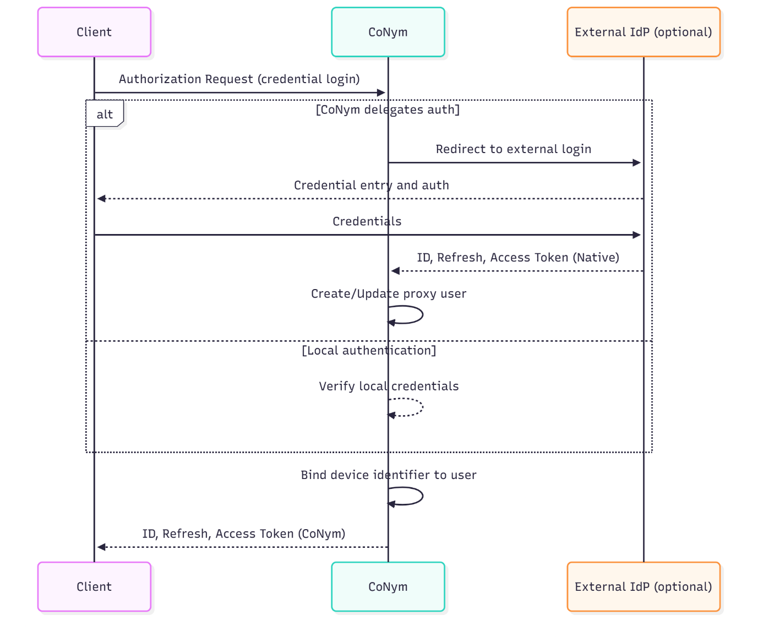
Outcome
- Device is authenticated and bound to the user.
- CoNym can later perform behavioural login for this user/device.
- Client receives standard OAuth/OIDC tokens.

Behavioural Data Ingestion (CA-Server → CoCoA)
Behavioral inference is performed entirely by the CA subsystem (HKA).
CoCoA only stores, decays, and aggregates the results.
Purpose
- Receive behavioural distance values for device identifiers.
- Maintain a time-decayed, source-aware history of behavioural values.
- Make aggregated results available to CoNym.
Sequence
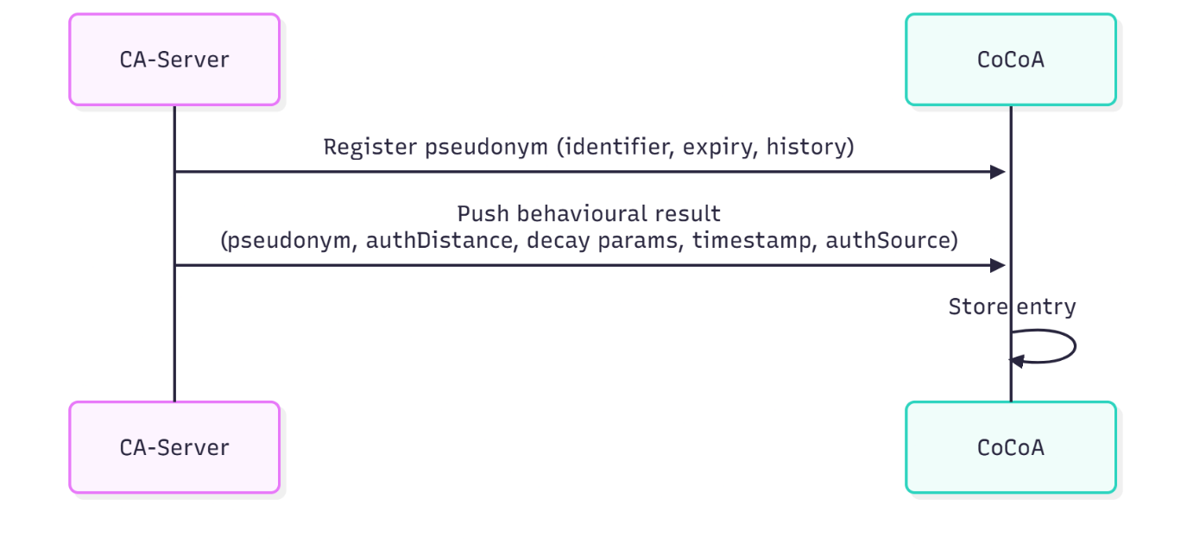
Notes
- CoCoA never evaluates behaviour; it only stores and aggregates.
- Decay uses parameters provided per entry by CA-Server.
- Aggregation (currently: median) occurs per request, source filtering rules apply.
- Only the last entry per authSource contributes to the effective behavioural score.

Behavioural Authentication Flow (Reauthentication)
After initial login, the client may reauthenticate using behavioural signals instead of credentials.
Purpose
- Provide passwordless / credential-less login when sufficient behavioural match exists.
- Maintain a seamless user experience across long sessions.
- Allow stricter or more lenient authentication depending on scopes.
Sequence
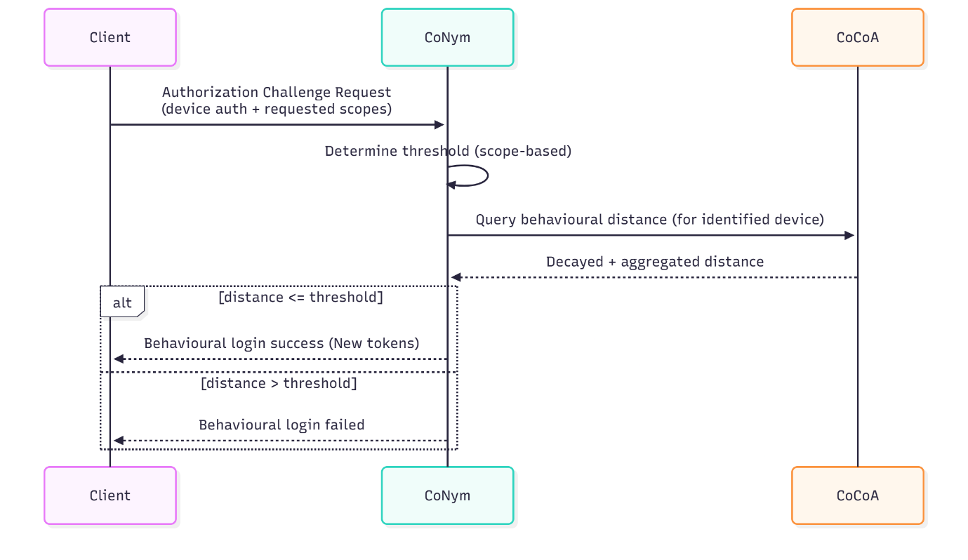
Outcome
- If behaviour is consistent with the bound user, a new token set is issued.
- Otherwise, credential login is required.

Using Services Through Proacc (Token Exchange)
The client uses Proacc to access services without implementing complex routing logic itself. Proacc injects the correct external access token and performs necessary identifier rewrites.
In the simplest configuration, Proacc acts purely as a router: it selects the target service and forwards the request without validation, token exchange, or rewrites. This is useful to give the client a single stable endpoint, even for unauthenticated requests.
Purpose
- Allow services to rely solely on RFC 8693 Token Exchange to accept CoNym identities.
- Allow a single client integration point even in multi-IdP or multi-provider ecosystems.
- Map CoNym identifiers to provider-local identifiers when required.
Sequence
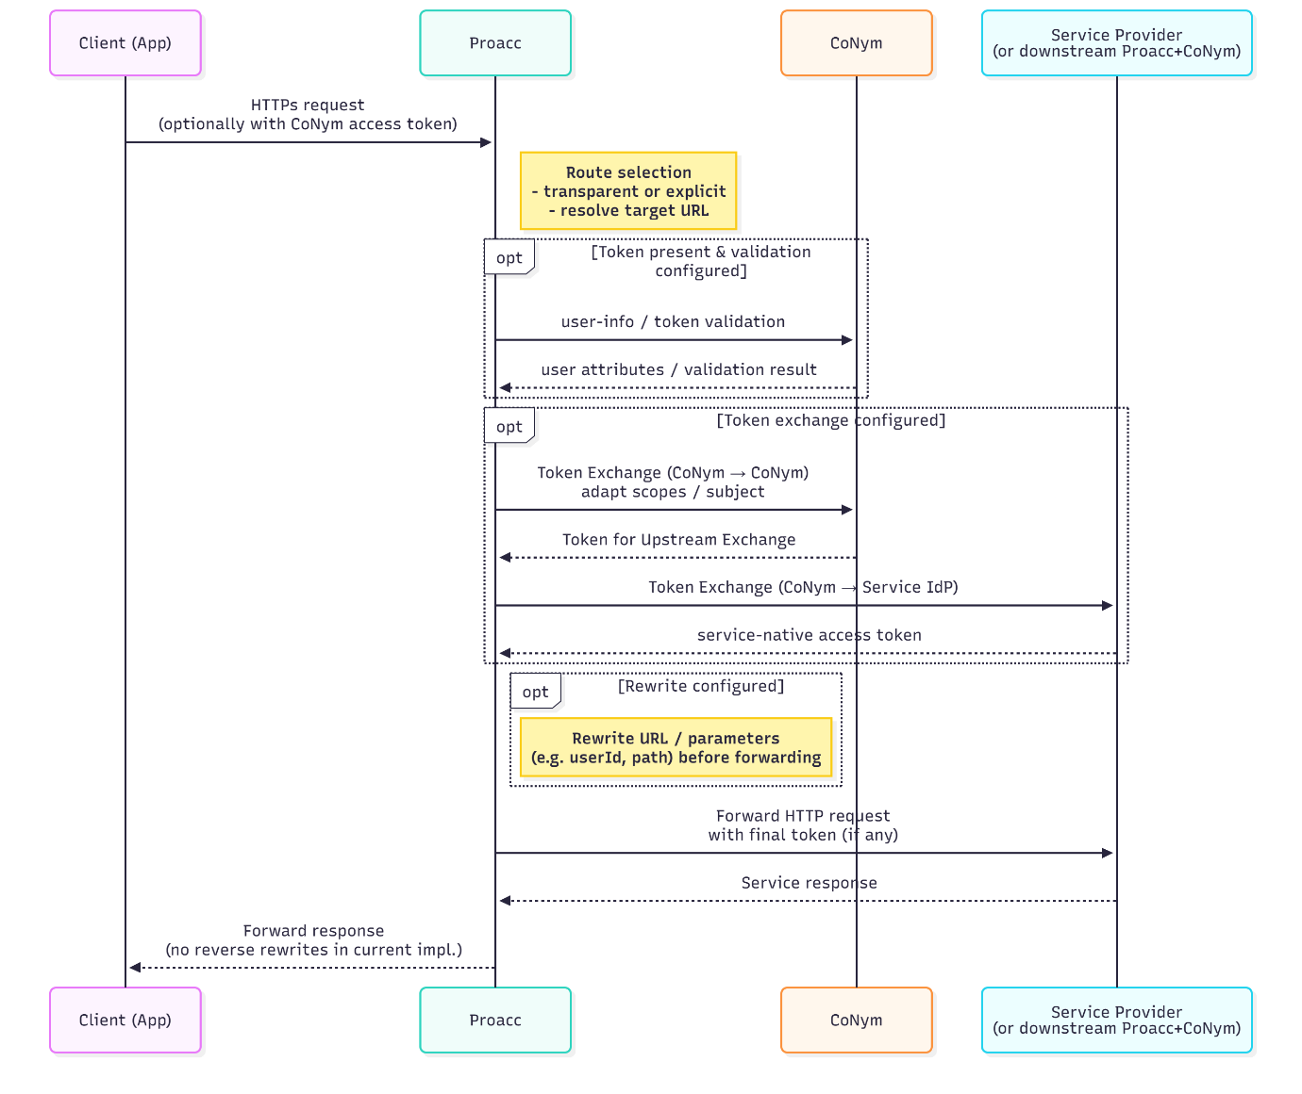
The ‘Service Provider’ in the diagram can also be another Proacc+CoNym pair, enabling multi-hop routing in larger ecosystems
Notes
- Proacc may use either:
  - transparent routing, or
  - explicit forwarding (forwardUri)
depending on configuration.
- Proacc modifies only what is necessary (mainly user identifiers, sometimes URL components).
- No inverse transformations are done on the response.

Pseudonym Email Forwarding (Postfix)
Postfix acts as a pseudonymous e-mail relay, resolving pseudonymised recipient addresses to real addresses.
Purpose
- Preserve email-based communication without exposing real addresses to external parties.
- Ensure incoming email addressed to pseudonyms reaches the correct user.
Sequence
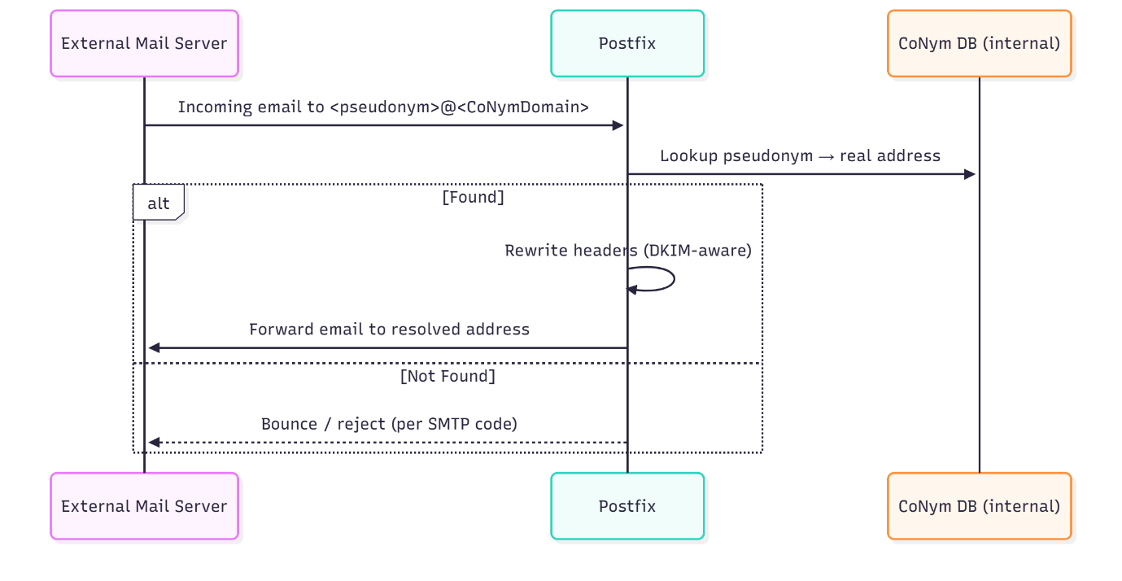
Notes
- CoNym’s DB is queried directly; this may change in future production deployments.
- Postfix rewrites headers only when safe (DKIM preserved).
- Always forwards; no local mailboxes are used.

Summary of Dataflows
Flow | Main Components | Trigger | Result
Standard Login | Client → CoNym (→ External IdP) | User action | ID + access token, device binding
Behavioural Data Ingestion | CA-Server → CoCoA | CA inference cycle | Stored behavioural distance values
Behavioural Authentication | Client → CoNym ↔ CoCoA | Token expiration or explicit request | Behavioural login success/failure
Token Exchange & Service Use | Client → Proacc → SP | API call from client | Provider access token + routed request
Pseudonym Email Forwarding | External Mail → Postfix | Email to pseudonym

Deployment & Production Considerations
This chapter outlines how the CoNym, CoCoA, Proacc, and Postfix components deployment structure in the current project setup is organized, what a production-ready deployment would require, and which architectural or operational limitations implementers must be aware of. A dedicated installation & configuration guide will complement this chapter with step-by-step instructions, environment setup, and concrete configuration examples.

Deployment Model
The system is delivered as a multi-container application using Docker Compose. Each core component runs in its own container (with separate containers for the databases):
- CoNym (Janssen + custom extensions)
  - MySQL (Jannsen & CoNym Storage)
- CoCoA (Spring Boot)
  - MariaDB (CoCoA Storage)
- Proacc (Jetty-based proxy)
- Postfix (email pseudonym relay)
- Nginx (reverse proxy)
- Certbot (automatic certificate management)
- Janssen Configurer (installs of Janssen configurations)
Two environment files control deployment and application configuration:
- .env.default – base parameters for all deployments
- .env.override – instance-specific overrides (secrets, hostnames, etc.)
The Docker Compose yaml merges both files, allowing development, integration, and field-test deployments to share the same repository without leaking sensitive values.

Reverse Proxy Layer (Nginx)
Nginx terminates TLS for all external traffic and routes requests to the correct internal component. It enforces:
- TLS / mTLS for external clients
- Segregation between externally accessible and internal-only endpoints
- Proxy rules for CoNym, CoCoA, and Proacc
A startup script dynamically generates the Nginx configuration from environment variables to allow flexible instance-specific deployment.

Janssen First-Start Behaviour (CoNym)
The official Janssen monolith Docker image performs a full installation step on first startup, which can take several minutes.
To avoid repeating this step, the deployment scripts behave as follows:
- On first Up: Uses the Janssen monolith resulting in the installation process.
- On first Down: Makes a snapshot of the fully installed image if install finished.
- On Subsequent Ups: Uses the snapshot, ensuring stable and repeatable startup without reinstalling.
This optimisation has also been contributed upstream to Janssens monolith deployment scripts. It is recommended to make a Down followed by an Up after the installation process.

Certificates and ACME Automation
A Certbot container is integrated to:
- Automatically obtain Let’s Encrypt certificates
- Renew certificates periodically
- Provide updated keys/certs to Nginx without manual intervention
Administrators must ensure DNS and firewall rules allow ACME challenges to succeed.

Production Considerations
Although the current setup is field-test ready, several aspects must be carefully considered before operating the system in a production environment.

Running Janssen in Docker Compose
The Janssen project officially states that the Docker Compose distribution is intended for development and testing, recommending Kubernetes/Helm for production deployments.
Practical choices for adopters include:
- Option A — Run Docker Compose in production:
Acceptable for controlled, small-to-medium deployments, provided operational risk is acknowledged, as well as for testing and further development.
- Option B — Harden the Compose deployment:
Review the Janssen installation scripts and the monolith to adjust them to ensure correctness and idempotency. Suitable if Kubernetes is not desired.
- Option C — Migrate to Janssen Helm charts:
Technically recommended upstream, but requires integrating CoNym, CoCoA, Proacc, Janssen Configurator, and Nginx into a Kubernetes-native setup.
Longterm the Option C should be desired. However, it requires additional effort compared to A.

Service-Specific Configuration
A correct production deployment requires amongst other things careful tuning of:
- Token lifetime, session lifetime
- Pseudonymisation settings
- Routing logic and pipeline configuration in Proacc
- Nginx exposure / firewall rules
- Allowed Identity Providers and trust relationships
- mTLS certificate management for CA-Server and internal diagnostics
- Postfix outgoing smtp configuration
Incorrect configuration can compromise interoperability, security, or user experience.
A dedicated installation and configuration guide will list required and optional parameters for each component.

Behavioural Authentication Activation
If behavioural authentication is enabled, the trust model must be clear:
Any entity with a valid client certificate for CoCoA can push behavioural results.
This implies full trust in certificate holders—malicious or compromised deliverers of Behavioural data, could inject incorrect distances, enabling impersonation or harassment (e.g., forced logouts).
This is not a flaw of behavioural authentication itself, but a deployment-time trust-boundary consideration. Implementers should combine behavioural authentication with strong credential-based login (e.g., password + second factor) if behavioural signals are used for reauthentication.

Postfix Integration (Email Forwarding)
The Postfix instance functions solely as a stateless pseudonym-rewriting forwarder, not as a mailbox server.
Deployment considerations:
- It rewrites only envelope and selected headers (To, X-Forwarded-For/To).
- It does not perform DKIM re-signing (Neither does it change signed attributes)
- Correct outbound relay configuration is required.
- High-volume or security-critical deployments should consider decoupling pseudonym-mapping from direct DB access (e.g., using webhooks or notification scripts provided by CoNym).

Operational Considerations

Monitoring & Logging
Operators should monitor:
- Nginx access/error logs
- Janssen/CoNym logs (auth events, script logs)
- CoCoA event logs
- Proacc routing logs
- Postfix mail queue and forwarding failures
In production, dedicated monitoring integration is recommended.

Backup & Recovery
Depending on the setup plenty of the persisted runtime data if not all of them are ephemeral. Meaning a recovery from a loss is possible. However, it may lead to new users getting logged out and needing to provide their credentials again, further pseudonyms may change. If Janssen was configured as Identity server managing its own users, or random persisted pseudonyms are used a back up of the Janssen DB is recommended. Further, a backup of all config and environments files is recommended, especially if they were changed.

Known Limitations
In addition to the already described aspects there are further limitations that may need to be addressed in a productive deployment.
CoNym and CoCoA
- Advanced Behavioural Analysis approaches (incl. Potential future versions of the CA-Server), may require adaptions to CoCoA and CoNym, like for example a more dynamic threshold computation (e.g. Threshold delivered by CA-Server).
- Using CoNym as full-blown OAuth 2.0 or OpenID Connect server and utilising a large range of it’s features could result in incompatibilities with the CoNym extensions.
(A exhaustive testing of all possible interaction was out of scope, due to the combinatorial complexity involved)
Postfix E-mail Handling
- Direct DB access from Postfix is not suitable for high-security production environments.
- No DKIM re-signing; some downstream servers may not accept rewritten emails
- Downstream Responses like failed delivery are not returned to the original sender (proxy is unidirectional currently)
Proacc Routing
- No token caching implemented
(can affect latency, especially in multi-hop routing scenarios).
- Complex multi-provider setups may require the implementation of additional rerouting tasks, that can select the target based on user/token information.
Deployment
- Running Janssen in Docker Compose is not officially recommended for production.
- No automated scaling or redundancy mechanisms are provided out of the box.
- Improvement in Monitoring aspects is recommended

Deployment Overview Diagram
This diagram summarises the deployment layout at a high level, showing connection between components, including external systems and used protocols.
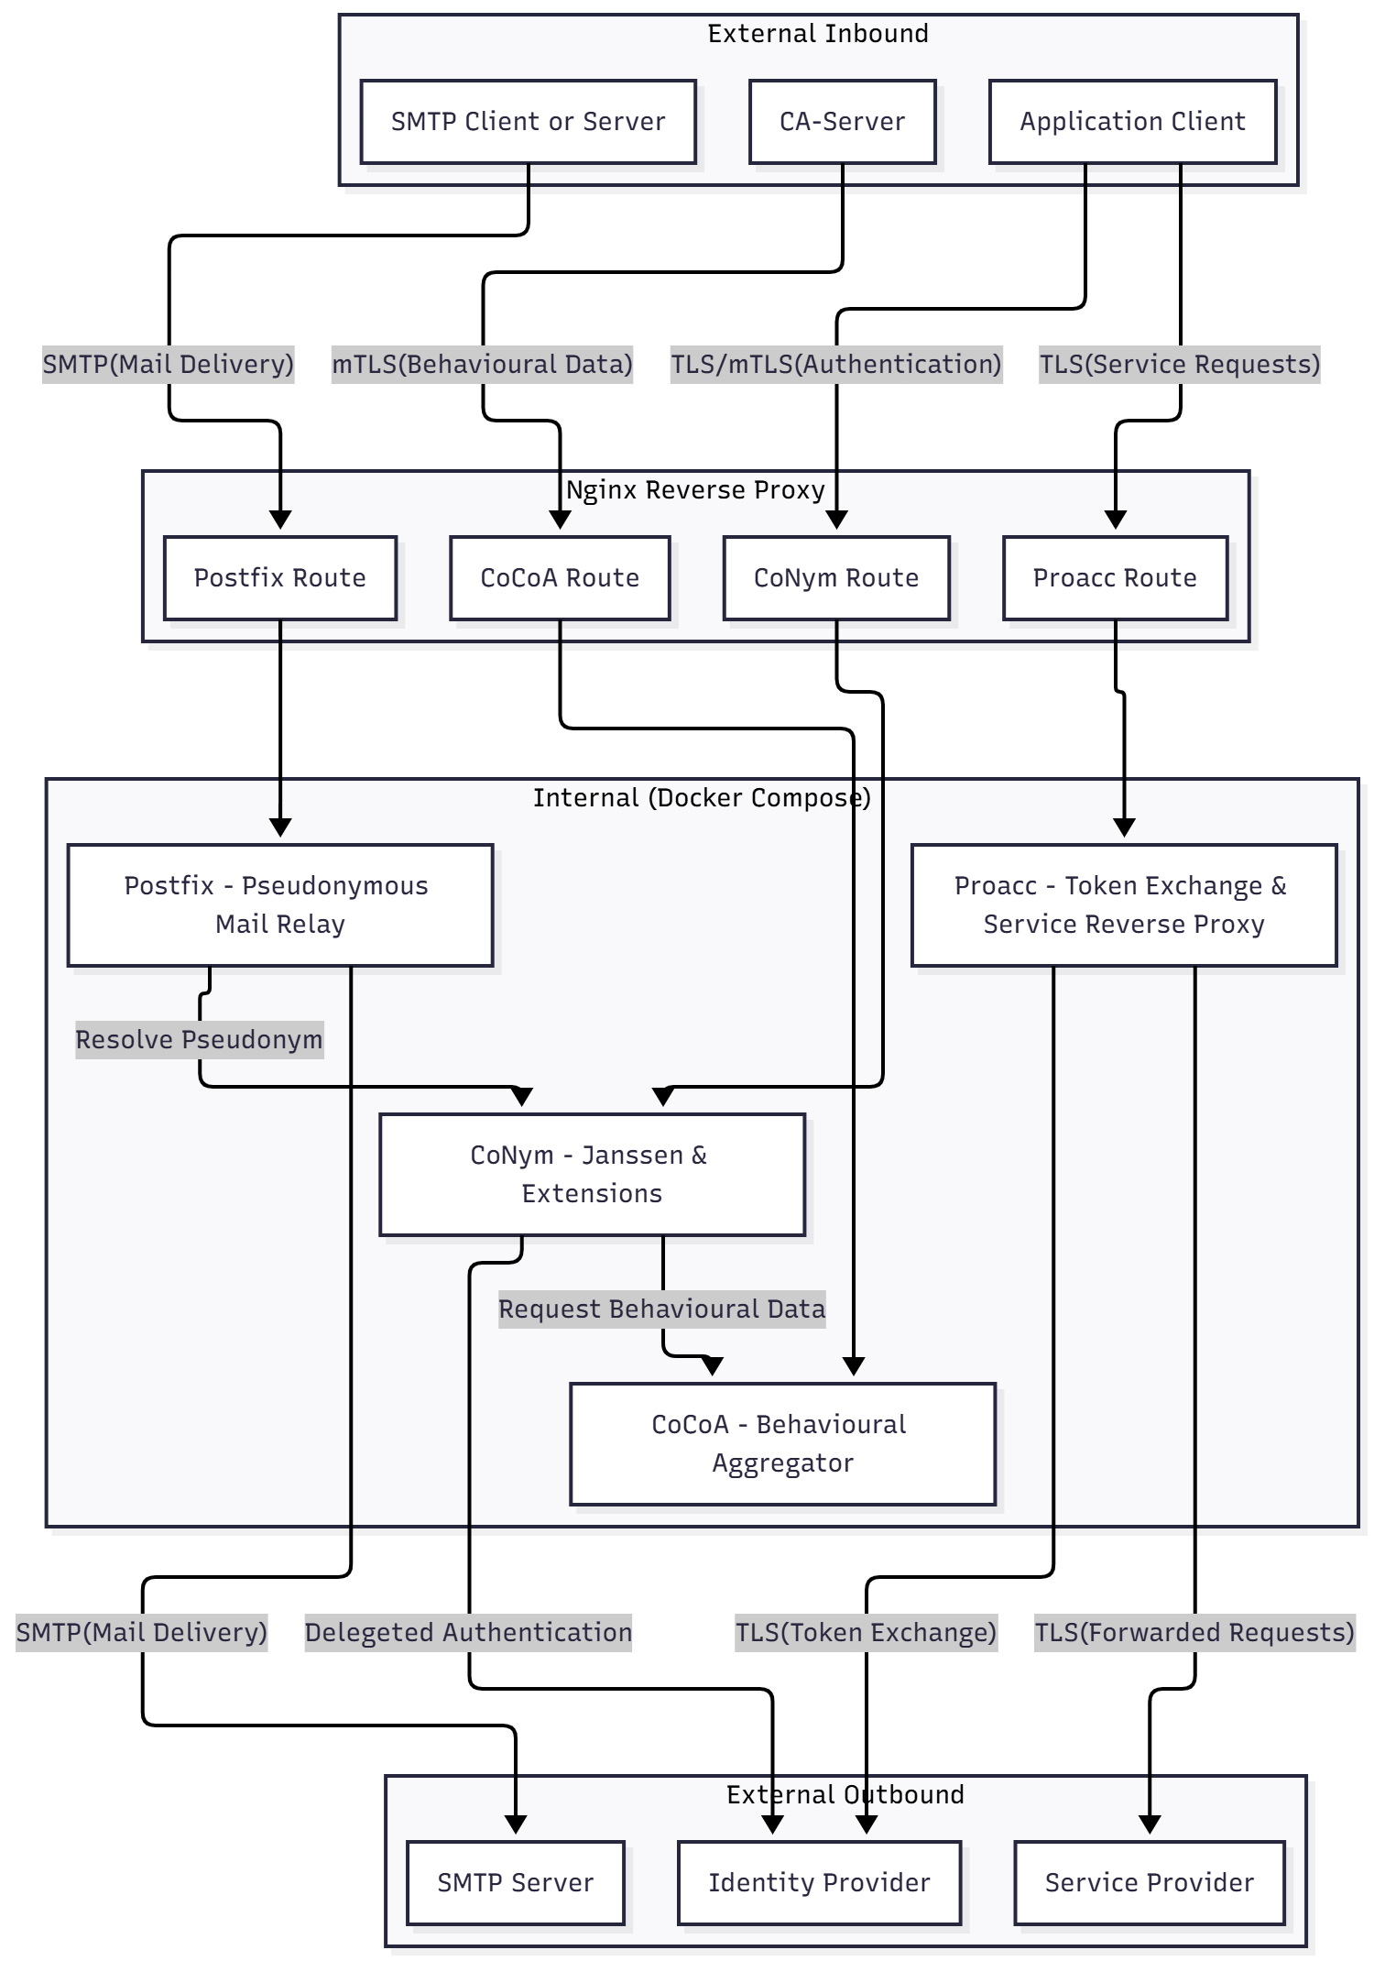
Part III — Implementation Details

Implementation
This section describes the implemented components. It will cover responsibilities and implementation strategies, as well as provided functionality. However, it will not cover concrete code, which can be obtained from the repository, or how to configure them which is in the installation and configuration guide.

CoNym – Janssen Integration

Shared Library: ConymJanssenBase
The shared library is located under
conym-extensions/ConymJanssenBase
inside the aura.ai repository.

Purpose and Design
ConymJanssenBase provides all core CoNym logic that extends the Janssen OAuth/OpenID Connect server.
All interception scripts (dynamic scopes, token updates, delegated auth, behavioural auth, etc.) deliberately remain thin: they handle script specific glue logic and translate Janssen’s script API calls into calls to manager classes provided by this library.
Design goals
- Centralise custom logic for authentication, CA behaviour, device handling, user/client mapping, and pseudonymisation.
- Keep scripts declarative—scripts decide when to invoke logic, and the managers decide how it works.
- Ensure consistency across different script execution points (update token, dynamic scopes, delegated authentication, authorisation challenge, etc.).
- Provide a single extension point for introducing new CoNym features or modifying existing behaviour.
- Isolate Janssen-specific integration so that the same internal logic is reused regardless of where it is triggered.
Deployment
Copy the compiled JAR into:
conym_docker/docker/janssen/template/custom/auth/libs
The startup script copies it into a folder mounted to:
/opt/jans/jetty/jans-auth/custom/libs
This directory is included on Janssen’s classpath for all custom scripts.
Runtime Model
- Scripts import and call methods on the managers.
- Managers expose their logic via static methods (avoids lifecycle ambiguity and circumvent limitation of Janssen's extension model).
- Managers do not run independently; they are always invoked from an interception script.
- All persistent state is stored in the CoNym extension database (co-located in Janssen’s MySQL instance).

Internal Structure
Conceptually, the library is built around five manager components:
- User Manager
- Client Manager
- Device Manager
- Claim Manager
- CA Manager (Continuous Authentication Manager)
- Database Table Classes (Wrappers around SQL queries to access the State)
Each manager encapsulates a concern and exposes methods geared towards the need of the interception scripts.

User Manager
Class: ch.fhnw.imvs.ai.aura.ConymUserManager
Responsibilities:
- Initial local user provisioning (optional; used only in setups with predefined local accounts).
- Proxy user lifecycle management:
  - Create local users mirroring external IdP identities.
  - Update attributes based on IdP claims (from tokens, UserInfo, etc).
  - Clean up expired or inactive proxy users.
- Identifier resolution:
  - Map external identifiers (issuer + subject, etc.) to local CoNym user Ids (proxy users).
  - Resolve local proxy user IDs back to external identifiers

Key Effects
- Maintains a stable mapping between external IdPs and local proxy identities.
- Shields scripts from handling low-level user mappings.
Provided Methods (static):
addUser(issuer, externalUserId, attributes)
Creates a new local proxy user for a user originating from an external IdP (issuer). Stores the user’s attributes so they can later be mapped into claims.
updateUser(localUser, attributes)
Updates the attributes stored on a proxy user, typically after delegated login.
findExtUser(issuer, externalUserId)
Looks up the local proxy user corresponding to a given external IdP (issuer) and external subject identifier.
resolveUser(subjectIdentifier, client)
Given a subject identifier (which may be pseudonymized), returns the corresponding local user. Uses client information, including it’s sector to decide how to find the User.
getProvider(localUser)
Returns the issuer (external IdP) that originally authenticated the user represented by the given local proxy user.
getExtUUid(localUser)
Returns the external subject identifier under which the external IdP (issuer) knows this user.
collectAttrsFromAllClaims(claimSet, targetedClaims)
Extracts relevant user attributes from a token or claim set and converts them into normalized types suitable for storage on a proxy user.
userAuthenticated(localUser)
Marks a user as having successfully authenticated. Used to prevent clean up of proxy users that are actively used.
registerDeleteNotifier(listener)
Registers a callback that is invoked whenever a proxy user is deleted. Used by the Claim Manager to clean up pseudonym mappings of expired users.

Client Manager
Class: ch.fhnw.imvs.ai.aura.ConymClientManager
Responsibilities
- Initial client creation (Proacc, external IdP clients, app clients).
- Security domain determination via sector URI or redirect URI:
  - Needed for pseudonymisation rules.
  - Needed to map subject identifiers appropriately.
  - Privileged clients (like Proacc) can overwrite by requesting a specific scope. (Used to generated tokens sent to other IdP’s for exchange)
Provided Methods (static):
fillClient(client)
Enriches a newly created or dynamically registered client with CoNym-specific configuration, such as associating scripts or applying required settings for pseudonymisation support.
findInvolvedIssuers(scopes, client)
Determines the issuer (security domain) relevant for pseudonymisation. Extracts issuer information either from:
- the client’s own sector configuration, or
- scope parameters indicating the intended consumer of a newly generated token (used heavily by Proacc).

Device Manager
Class: ch.fhnw.imvs.ai.aura.ConymDeviceManager
Responsibilities
- Device authentication
  - Validate device ID + secret, or
  - Validate via client certificate (mTLS).
- Deterministic device identifier generation
  - Must match CA-Client / CA-Server logic.
- Device-to-user binding
  - Bind device during first successful credential login.
  - Maintain association per client (security-domain check).
  - Rebind when a new user logs in on the same device.
Provided Methods (static):
getDeviceIdIfPresent(request)
Extracts and validates device authentication information from the incoming HTTP request (either device secret or client certificate). Returns the derived deterministic device identifier.
bindUserToDeviceIfPresent(request, client, user)
If a device authentication mechanism is present in the request the device is authenticated and bound to the given user. Also stores which OAuth client was used during binding as a protection measure.
getDeviceId(user)
Returns the deterministic device identifier currently bound to the given user, or null if the user has not yet been bound to a device.
getBoundUser(deviceId, clientId)
Resolves the local user bound to a given device identifier and verifies that the last binding was established using the same OAuth client (defensive check against cross-client misuse).
//Todo: Device id derivation mechanism

Claim Manager
Class: ch.fhnw.imvs.ai.aura.ConymClaimManager
Responsibilities
- Pseudonymisation logic
  - Decide per claim:
    - omit,
    - return plain,
    - return pseudonym.
- Modify claim sets
  - Apply pseudonymisation to:
    - ID tokens,
    - access tokens,
    - UserInfo responses.
- Pseudonym lifecycle
  - Deterministic vs random generation.
  - Persistence vs transient.
  - Different pseudonyms per sector.
  - Automatic deletion when users are deleted.
- Optional external notification (REST or shell-script callbacks).
Provided Methods (static):
modifyClaims(user, client, scopes, claims)
Applies the pseudonymisation policy to an existing claim set (ID token, access token, or user-info output).
Removes or pseudonymises claims according to configuration and returns the pseudonymized subject identifier.
getSubClaim(user, client, scopes)
Returns the subject identifier appropriate for the client’s sector.
Creates a pseudonym if none exists and returns it (or the plain subject if the sector permits).
supportedClaims(includeHidden)
Returns a list of all claim types known to the pseudonymisation engine.
If includeHidden is true, includes claims that are configured to be dropped entirely.
//Sector aware identifier Model – used keys etc.. (PAIRWISE vs. Public??)
//Pseudonymisation algos

CA Manager (Continuous Authentication Manager)
Class: ch.fhnw.imvs.ai.aura.ConymCAManager
Responsibilities
- Querying CoCoA for current behavioural distance.
- Determining effective threshold based on:
  - Base configuration,
  - Scope-dependent adjustments.
- Decide a pass/fail for behavioural authentication.
Provided Methods (static):
doCAAuth(scopes, subjectIdentifier, clientId, deviceId)
Performs the behavioural authentication evaluation.
- Builds the CoCoA query endpoint for the given device from a configurable template.
- Retrieves the behavioural distance.
- Computes the threshold based on configuration plus optional scope-specific adjustments.
- Returns true if the distance satisfies the threshold; otherwise, false.
//Todo: Threshold extraction algorithm

Lifecycle and Initialisation
- The library is loaded once into the JVM running Janssen via the custom libs directory.
- Each script instantiation triggers manager initialisation:
- Load config (JSON files, etc.).
- Perform one-time setup (optionally seed users/clients).
- Prepare caches.
- Managers behave like singletons within the JVM (using static methods):
- Shared state, consistent across all scripts.
- No per-script duplication.
When extending or modifying behaviour
- Locate the appropriate manager.
- Implement or update logic there.
- Keep scripts thin: they should only:
  - Choose the correct manager methods,
  - Provide context,
  - Integrate with Janssen’s flow.

Interception Scripts
CoNym’s custom behaviour in Janssen is realised through a set of interception scripts.
Each script is attached to a specific Janssen extension point (e.g. update token, authorization challenge, dynamic scope) and is intentionally kept thin: it only contains aspects specific to the integration and mostly translates Janssen’s callback API into calls to the manager classes in the ConymJanssenBase shared library.
The main design principles are:
- Separation of concerns:
  - Scripts deal with when to react in the OAuth/OIDC flow.
  - Managers in the shared library implement what to do.
- Consistency:
Similar behaviour (e.g. pseudonymisation, device binding) is always implemented via the same manager methods, independent of which script triggered it.
- Configurability:
Which scripts are active and how they behave is controlled by JSON configuration (see installation/configuration guide), not hard-coded in the script logic.
The scripts are located under
conym-extensions/JanssenScripts
inside the aura.ai repository.
Deployment
Copy the scripts and corresponding configs to:
conym_docker/docker/janssen/extension
The janssen configurator will deploy and configure them on startup:
The following subsections describe the main scripts and their responsibilities.

BehaviouralAuthentication (Authorization Challenge Script)
Extension point: Janssen authorization_challenge script
Class: BehaviouralAuthentication (Java)
Purpose
This script implements the behavioural authentication flow via the OAuth 2.0 authorization-challenge endpoint:
- Handles requests for the “behavioral_auth” acr value to /jans-auth/restv1/authorize-challenge advertised in the OIDC discovery document.
- Enables a client to request behaviour-based reauthentication when an existing token has expired or a new login should be attempted without credentials.
Core behaviour
- Uses Device Manager to:
  - Extract and validate the device identity from the current request
(device credentials or client certificate).
- Uses CA Manager to:
  - Query CoCoA for the current behavioural distance for that device.
  - Compute the effective threshold based on configured defaults and requested scopes.
  - Decide whether the behavioural check passes.
If the behavioural check passes, the script signals success to Janssen, so the normal token issuance logic (via UpdateToken) can proceed.
Deployment Note: Not deploying this script, disables the functionality to explicitly request behavioural authentication.

UpdateToken (Token Update Script)
Extension point: Janssen update_token script
Class: UpdateToken (Java)
Purpose
This script is invoked whenever Janssen issues or refreshes tokens. It is the central hook for:
- Device binding (user ↔ device association).
- Applying pseudonymisation to token claims.
- Adjusting token lifetimes based on scopes.
Core behaviour
- Uses Device Manager to:
  - Authenticate the device present in the request (if any).
  - Bind the current user to this device for subsequent behavioural logins.
    - Binding also records the client that was used, to enforce that only the same client can later use that binding.
- Uses Claim Manager to:
  - Apply pseudonymisation rules to claim sets that end up in:
    - ID tokens,
    - access tokens.
  - Generate or look up the appropriate subject identifier for the target sector.
- May adjust token lifetime based on the required scopes and the required threshold associated with those scopes.
Deployment Note: This script is essential, as it is required for both behavioural authentication and pseudonymisation and not deploying it will lead to an unsafe system.

PostAuthn (Post Authentication Script)
Extension point: Janssen post_authn script
Class: PostAuthn (Java)
Purpose
Janssen, OAuth 2.0 in general, normally allows sessions: if a browser still has a valid session, the user can be logged in again without entering credentials (“remember me” behaviour). The PostAuthn script lets CoNym intercept that process and optionally enforce a behavioural check before the session is reused.
Core behaviour
- After an Authentication, if the last credential-based authentication wasn’t recent (session was reused) it doea a behavioural authentication and forces reauthentication if that fails.
- To do so, uses:
  - Device Manager to identify the device behind the session, and
  - CA Manager to re-check the behavioural distance for that device.
Deployment Note: Not deploying this script is fine but depending on the Janssen configuration may lead to cases where behavioural data is ignored if their is still an active session.

ClientRegistration (Dynamic Client Registration Script)
Extension point: Janssen client_registration script
Class: ClientRegistration (Java)
Purpose
Handles dynamic client registration when it is enabled. In many deployments, registration is done via configuration files, and this script is rarely used at runtime; however, it remains useful for testing and specialised setups.
Core behaviour
- Can fully disable dynamic client registration if not desired.
- If enabled, uses Client Manager to:
  - Inject CoNym-specific configuration into newly created clients (e.g. attach the CoNym scope, link relevant scripts).
  - Align client configuration with CoNym’s pseudonymisation and authentication expectations (e.g. subject type, required scopes).
Deployment Note: If Dynamic client Registration is enabled, then this script is required. Otherwise, the dynamically generated clients can not use CoNym functionality.

DelegatedAuthentication (Custom Authentication Script)
Extension point: Janssen person_authentication script
Class: DelegatedAuthentication (Java)
Purpose
Implements delegated authentication where CoNym acts as an OAuth 2.0 client to external IdPs, but still appears as a single logical IdP to calling applications.
Core behaviour
- Decides which IdP to delegate to, based on:
  - Client configuration,
  - Requested scopes,
  - Or explicit user choice (via a custom login page with a dropdown).
- Or falls back to local authentication (CoNym as IdP) if so configured.
- Handles the full delegated flow:
  - Redirects to the external IdP.
  - Receives the response.
  - Validates the response and extract’s identity information.
- Uses User Manager to:
  - Find or create the corresponding local proxy user.
  - Map external identifiers and attributes into the local user representation.
- Integrates with other managers where needed (e.g. Claim Manager for initial attribute mappings).
Deployment Note: Not deploying this would disable delegated authentication. However, it should always be deployed, if no delegation is required it should be configured to use local authentication. The reason is, that it was not sufficiently tested if everything works as expected without this script.

DelegatedConsentGathering (Consent Script)
Extension point: Janssen consent_gathering script
Class: DelegatedConsentGathering (Java)
Purpose
Controls the consent screen behaviour when delegation chains are involved.
Without this script, every IdP in the chain (including CoNym itself) would ask for consent separately, leading to repeated and confusing consent prompts.
Core behaviour
- Suppresses or simplifies local consent prompts when:
  - An upstream IdP is already responsible for consent, and
  - All requested scopes are in the exempt list configured for that IdP.
- Can auto-approve consent in cases where:
  - The scopes requested are known and accepted by configuration.
  - The user has previously granted consent upstream
(implicit if upstream authentication succeeded).
Deployment Note: Not deploying this means that Janssen will display a consent form even if the user has already given consent for a scope during upstream authentication. If delegated auth is not used, this script can safely be skipped from deployment.

ConymUserInfo (Dynamic Claims Script)
Extension point: Janssen dynamic scope / user info script
Class: ConymUserInfo (Java)
Purpose
Implements CoNym’s dynamic scope for pseudonymisation-aware claims.
Clients that have the conym scope receive have the claims returned from the userinfo endpoint generated by this script.
Core behaviour
- Declares which claims are handled by the CoNym scope (those affected by pseudonymisation).
- Uses Claim Manager to:
  - Populate claim values for user-info responses and other claim sets.
  - Apply pseudonymisation rules consistently with the configuration.
- Works together with the UpdateToken script, which handles claims embedded directly in tokens; ConymUserInfo focuses on user-info and dynamic claim materialisation.
Deployment Note: If this script is not deployed the user-info endpoint will disregard pseudonymisation and always return the original ones.

TokenExchange (Token Exchange Script)
Extension point: Janssen token_exchange script
Class: TokenExchange (Java)
Purpose
Provides a specialised token exchange endpoint (a authorization challenge endpoint) used primarily by Proacc and potentially by other future components in multi-hop scenarios.
It extends Token Exchange support by:
- Making it easier for Proacc to request tokens that are tailored for a specific downstream service or security domain.
- Adding some additional context that helps in multi-hop routing and identifier handling.
Core behaviour
- Accepts incoming requests where the access token is valid.
- Uses Client Manager to:
  - Interpret which issuer / security domain the requested token should target and validates that it is an approved one.
- Associates the user with the grant
  - Allows the client to get the Token at the Token exchange
Deployment Note: Not deploying this means that Proacc can not prepare a token for consumption of an upstream token exchange. If the upstream token exchange is in the same security domain or claims are not pseudonymized it can still work.

Authorisation Challenge Endpoints API
Authorisation Challenges are a way to extend OAuth 2.0 with custom authentication mechanisms, that do not require credential inputs. Instead of the user providing credentials to get an code grant, that the client can exchange for tokens, the client can directly get the code grant over a request to the authorization challenge endpoint providing. Depending on the specified acr value Janssen chooses a script that uses the request content to perform the authentication. The two scripts BehaviouralAuthentication and TokenExchange handle authorisation challenges and thus require additional parameters not defined in the standard. However, standards like PKCE, PAR, scope choices are supported.

BehaviouralAuthentication API
Standard Parameter Choices:
acr_values=behavioral_auth
response_type=code
Extra Parameters:
device=<DeviceId>
device_secret=<DeviceSecret> //Is not needed if mTLS authentication is used

TokenExchange API
Standard Parameter Choices:
acr_values=token_exchange
response_type=code
Extra Parameters:
issuer=<IssuerOfTheUser>
access_token=<accessToken>

CoCoA – Behaviour Aggregation Service

Application Structure
CoCoA is implemented as a standard Spring Boot 3.2.4 application (Java 21), backed by MariaDB 11.
Core components:
- CocoaApplication
  - Main Spring Boot entrypoint (starts the embedded servlet container).
- ServletInitializer
  - Allows deployment in traditional servlet containers (Spring Boot WAR support).
- Controllers
  - AuthenticationController – REST API for behaviour ingestion and behavioural status queries.
  - LogController – REST API for accessing the diagnostic log (for HKA/testing).
- Repositories
  - AuthenticationRepository – database access for the “current” behavioural results and/or per-source entries.
  - LogRepository – database access for the historical log used for inspection.
- Security
  - SecurityConfiguration – Spring Security configuration, including optional client CA checking.
  - SubjectDNAuthenticationFilter – extracts client identity and client CA verification result (added by nginx).
  - SubjectDNAuthenticationProvider – authenticates requests based on the filter result.
The application is packaged as a Docker image and run as a dedicated container in the Docker Compose setup.

Security and mTLS Authentication
All write access (ingestion of behavioural results, registration of pseudonyms) is restricted to authenticated clients using mutual TLS. The CoCoA container itself does not handle TLS termination; this is done at nginx, but if enabled CoCoA still checks the client certificate information being forwarded (e.g. via X-SSL-Client-DN or similar, depending on nginx configuration), and thus can still work if the mTLS client CA check is configured as optional in nginx.
Effectively, CoCoA trusts the CA-Server based on its certificate:
If you hold the right client certificate, you can send behavioural results. This is why the certificate issuance process and distribution are security critical.

Behavioural Data Model
CoCoA’s behaviour data model is centred around device pseudonyms and per-source behavioural distances.
Per ingested behavioural result, CoCoA stores:
- Device pseudonym
  - The opaque device identifier used by both CoNym and the CA-Server.
  - Generated by the CA-Client and shared with the OAuth client on the device so that both paths (device auth via CoNym, behavioural data via CA-Server → CoCoA) refer to the same identifier.
- Distance value
  - A numeric value representing the deviation from the device’s baseline behaviour.
  - 0 means “perfectly matches baseline”, 1 means “maximally different” (equivalent to “completely untrusted”).
  - Values in between represent decreasing confidence.
- Decay function parameters
  - Parameters that control how the distance changes over time:
    - decayTime, parameterA, parameterK (names from CA-Server payload).
  - These parameters are chosen by the CA-Server and specify the time-based decay model for this result.
- Timestamp
  - When the CA-Server generated the result (authTimestamp).
  - If omitted, CoCoA falls back to its own ingestion time.
- Source identifier (authSource)
  - Identifies the behavioural channel or model that produced the result (e.g. accelerometer, touchscreen, or a specific model variant).
  - Each stored result belongs to exactly one source.
- Log retention metadata
  - A history value is defined when a pseudonym is registered. This indicates how many entries per authSource CoCoA should keep in the log for that pseudonym for inspection and testing.
CoCoA maintains two conceptual layers of data:
- Current per-source state
  - At most one “active” entry per (pseudonym, authSource) is used for computation (the last received value).
  - Older entries are kept only according to the history limit.
- Historical log
  - Additional entries beyond the “current” one are kept for debugging and verification purposes and are accessible via Log endpoints.

Registration, Ingestion, and Query Flow
CoCoA’s interaction pattern with the CA-Server and CoNym can be summarised as follows.

Pseudonym Registration (CA-Server → CoCoA)
Before the CA-Server can submit behavioural results for a device pseudonym, it must register the pseudonym with CoCoA.
The registration request contains at least:
- Device pseudonym (pseudonym)
- Expiration time for this pseudonym
- History value (how many past entries per authSource to keep for the log)
The registration:
- Creates or updates a pseudonym record in CoCoA’s database.
- Ensures that CoCoA knows:
  - Which pseudonyms are active.
  - How long they are valid.
  - How many historical entries per source to keep.
Pseudonyms that reach their expiration are eventually cleaned up, together with their behavioural entries.

Behavioural Result Ingestion (CA-Server → CoCoA)
After registration, the CA-Server periodically pushes behavioural results for the registered pseudonym.
Each push includes:
- pseudonym – the device identifier.
- authDistance – the distance value (0–1).
- decayTime, parameterA, parameterK – the decay function parameters.
- authTimestamp – when the result was computed (optional).
- authSource – source/channel of the behaviour (mandatory on ingestion).
CoCoA:
- Authenticates the CA-Server via nginx added Headers (if client CA validation is optional).
- Validates that the pseudonym is known and not expired.
- Stores the new entry for (pseudonym, authSource):
  - Updates the “current” value for that source.
  - Keeps previous entries up to the configured history limit.
- Records the entry in the log table, so it can be inspected later through the LogController.
No behaviour evaluation is done here; CoCoA simply stores the data and notes how to decay it over time.

Behavioural Distance Lookup (CoNym → CoCoA)
When CoNym needs to perform a behavioural authentication, it queries CoCoA for the current distance for the device pseudonym.
The query contains:
- Device identifier / pseudonym.
- Optionally an authSource selector:
  - If a concrete authSource is specified:
    - CoCoA returns the decayed distance for that specific source only (no aggregation).
  - If authSource is missing:
    - CoCoA returns the decayed distance for the default source (named default by convention).
  - If authSource is an empty string (""):
    - CoCoA:
      - Retrieves the last entry for each source for the given pseudonym.
      - Applies the decay function per entry based on the time elapsed since its timestamp.
      - Aggregates the per-source distances into a single value (currently using the median as aggregation function).
      - Returns this aggregated distance to CoNym.
In all cases, CoNym receives a single numeric distance value, which it then compares against a threshold (possibly scope-dependent) to decide whether behavioural authentication succeeds.

Log API and Diagnostics
The LogController exposes the internal log of behavioural entries so that HKA and integrators can verify whether:
- Results arrive at CoCoA as expected;
- The decay and aggregation behave as intended over time.
Characteristics:
- Access is restricted via the same mTLS-based Subject DN authentication as the ingestion API.
- Typically used by opening the endpoint in a browser that has the appropriate client certificate installed.
The log is not intended for production monitoring dashboards, but as a debugging aid during integration and testing.

REST JSON API (Summary)
This subsection summarises the CoCoA REST API as exposed by AuthenticationController and LogController.
All endpoints produce JSON and are mounted under the CoCoA base URL (e.g. https://<domain>/cocoa/...).

/authenticate – Behavioural State API
All routes under /authenticate are JSON-based and protected; write operations (POST/PUT/DELETE) are intended for the CA-Server, while reads (GET /authenticate/{pseudonym}) are used by CoNym during behavioural authentication. As nginx serves as mTLS termination, services on the internal network (like CoNym) can access the GET endpoints without using mTLS.
GET /authenticate
Returns a paged list of registered pseudonyms.
- Query parameters
  - skip (optional, integer ≥ 0, default 0): number of pseudonyms to skip (offset).
  - limit (optional, integer ≥ 1, default 10): maximum number of pseudonyms to return.
- Response
  - 200 OK with body: ["pseudonym-1", "pseudonym-2", "..."]
  - 403 Forbidden if the caller is not authorised
POST /authenticate
Registers a new pseudonym (device identifier) and its retention parameters.
- Request body — PseudonymRegistration
{
"pseudonym": "device-pseudonym-123", // required
"expiry": 30, // optional, days of inactivity before cleanup (1–720, default 30)
"history": 100 // optional, entries per authSource to keep in log (≥1, default 100)
}
  - pseudonym
Unique device identifier used by both CA-Server and CoNym
  - expiry
Number of days after the last update after which the pseudonym and its entries may be deleted.
  - history
Maximum number of historical entries per authSource kept for inspection in the log.
- Response
  - 204 No Content – pseudonym successfully registered.
  - 208 Already Reported – pseudonym already exists (request is effectively idempotent).
  - 4xx – validation errors (e.g. expiry out of range).
  - 403 Forbidden – caller not authorised to register pseudonyms.
GET /authenticate/{pseudonym}
Returns the current behavioural status of a single pseudonym.
- Path parameter
  - {pseudonym} – device pseudonym (string).
- Query parameter
  - authSource (optional, string): selects which behavioural source(s) to consider:
    - omitted → use "default" source.
    - "someSource" → return distance for that specific authSource only.
    - "" (empty string) → aggregate across all available sources (median of per-source distances).
- Response
  - 200 OK with body — PseudonymStatus:
{
"authDistance": 0.42,
"timestamp": 1700000000,
"authSource": "",
"authSources": {
"default": 0.42,
"motion": 0.51,
"touch": 0.38
}
}
    - authDistance
Decayed distance value used for authentication (0.0 = identical to baseline, 1.0 = maximally different). If authSource = "", this is the aggregated (median) distance across all sources. If a concrete authSource is requested, this is the decayed distance for that source.
    - timestamp
Server-side time (seconds since epoch) at which the lookup was performed.
    - authSource
Effective source selector used for this computation:
      - "default" if no authSource parameter was provided,
      - "" if median mode was requested,
      - or the specific source name if a concrete source was requested.
    - authSources
Map from authSource name → decayed distance for that source (only sources with distance < 1.0 are included).
  - 404 Not Found – pseudonym not known or has no usable entries (effectively equivalent to distance 1.0 for most clients).
  - 403 Forbidden – caller not authorised to query this pseudonym.
PUT /authenticate/{pseudonym}
Stores a new behavioural authentication result for a pseudonym.
- Path parameter
  - {pseudonym} – device pseudonym (must already be registered).
- Request body — AuthenticationUpdate:
{
"authDistance": 0.23,
"authSource": "default",
"timestamp": 1700000000,
"decayTime": 300,
"parameterK": 0.1
}
Fields:
  - authDistance (required)
Distance in [0.0, 1.0]. Values outside this range are rejected.
  - authSource (optional, string)
Name of the behavioural source/channel. If omitted, "default" is used.
  - timestamp (optional, long)
Time (seconds since epoch) at which the CA-Server computed the distance.
    - If omitted → CoCoA uses its current time.
    - If present → must be within ±30 seconds of CoCoA’s current time; otherwise rejected.
  - decayTime (optional, integer ≥ 1)
Characteristic time window (seconds) that the decay function uses. Defaults to 300 if omitted.
  - parameterK / parameterA (optional, double)
Mutually exclusive parameters that select and parameterise the decay behaviour:
    - Only one of them may be non-null; having both set results in an error.
    - parameterK must not be 0.0.
    - parameterA must not be 0.0 and must avoid a small invalid interval near (authDistance - 1.0).
- Response
  - 204 No Content – update accepted and stored.
  - 404 Not Found – pseudonym does not exist (registration missing or already cleaned up).
  - 4xx – validation errors for authDistance, timestamp, or decay parameters.
  - 403 Forbidden – caller not authorised to push updates.
DELETE /authenticate/{pseudonym}
Deletes a pseudonym and all associated behavioural entries.
- Path parameter
  - {pseudonym} – device pseudonym.
- Response
  - 204 No Content – pseudonym and associated data deleted.
  - 404 Not Found – pseudonym not known.
  - 403 Forbidden – caller not authorised to delete pseudonyms.

/log – Diagnostic Log API
The /log endpoint exposes a paged view of CoCoA’s internal log table.
GET /log
Returns recent log entries in reverse chronological order.
- Query parameters
  - skip (optional, integer ≥ 0, default 0): number of entries to skip (offset).
  - limit (optional, integer ≥ 1, default 10): maximum number of entries to return.
- Response
  - 200 OK with body — array of LogEntry:
[
{
"timestamp": 1700000000,
"pseudonym": "device-pseudonym-123",
"authSource": "default",
"message": "Registering pseudonym with expiry 30 and history 100."
},{
"timestamp": 1700000050,
"pseudonym": "device-pseudonym-123",
"authSource": "default",
"message": "Distance 0.20000 decayed to 0.23000"
}]
    - timestamp – log entry time (seconds since epoch).
    - pseudonym – optional pseudonym associated with this log entry (may be null).
    - authSource – optional source name (may be null for generic messages).
    - message – human-readable log message.
  - 403 Forbidden – caller not authorised (e.g. missing client certificate).

Proacc – Proxy Implementation
Proacc is implemented as a standalone Java 21 application running on Jetty 12.
The main entry point is:
ch.fhnw.imvs.ai.aura.access.proxy.ConymAccessProxy,
which starts the Jetty server, loads configuration, and wires up the proxy servlets.

Startup and Configuration
On startup, ConymAccessProxy performs the following actions:
- Load configuration
  - Reads a JSON configuration describing:
    - Known issuers (IdPs / CoNym instances), including endpoints and client credentials.
    - Routes, for each target URI that should be handled, including a list of tasks to execute on a match
    - Transparent endpoint mappings: base paths on Proacc mapped to target service hosts.
- Start Jetty
  - Configures and starts an embedded Jetty server.
  - Registers servlets for:
    - Explicit forwarding (parameter mode): ParamProxyServlet.
    - Transparent forwarding: multiple TransparentProxyServlet instances, one per configured transparent endpoint.
The initialisation of the issuer from the config is delayed until the first request arrives. This is done to make it less fragile in case a issuer (like CoNym) starts in the same docker compose and thus may not be available for requests when Proacc loads the config

Servlets and Routing
All proxy servlets share a common abstract superclass:
AProxyServlet
Implements the generic processing pipeline and HTTP forwarding logic.
It leaves one abstract concern to subclasses:
- extractForwardUri(request) -> targetUri
Concrete subclasses differ only in how they derive the initial target URI.
ParamProxyServlet (Explicit Mode)
- Mounted at a configurable forward endpoint (e.g. /forward).
- Extracts the forward URI from a query parameter named forward-uri.
This mode is especially useful in explicit multi-hop Proacc setups, where upstream Proacc instances can pass routing metadata downwards.
TransparentProxyServlet (Transparent Mode)
- Multiple instances are mounted, one per configured transparent mapping.
- Each mapping defines:
  - A base path on Proacc (e.g. /init-api).
  - A target host (e.g. api.init-services.example).
- When a request arrives at a transparent endpoint, the servlet:
  - Matches the base path.
- Constructs the initial target URI by replacing the base path with the configured target host while preserving the remaining path and query parameters.
This mode is especially useful for retrofitting existing clients clients: they can simply change the host to Proacc and keep all paths unchanged.
Both servlet types then delegate to AProxyServlet for the rest of the processing.

Request State and Route Matching
To avoid recomputing helper information for each task, Proacc uses an immutable “state” object that flows through the pipeline. Tasks consume a state object and can return a “state” object with changed values:
State contents (conceptual):
- targetUri: Current target URI
- request: Original incoming HTTP request (headers, method, body).
- accessToken (optional): Token extracted from the incoming request (e.g. Authorization header).
- info (optional): User-info JSON object, obtained via the token’s userinfo endpoint.
- issuer (optional): Issuer configuration entry (JSON) resolved from config.
- issuerTrust (optional): Trust store / TLS context to contact that issuer (constructed from config).
The state is updated in a functional style: withXxx(...) methods return new state instances with one field changed and dependent fields.
Route selection:
- The initial targetUri is determined by the servlet (extractForwardUri).
- AProxyServlet iterates over all configured routes and selects the first whose regex pattern matches the targetUri.
- The regex match result is stored in a RouteVariables object:
  - Supports positional and named capture groups.
  - Variables can be reused by tasks and configuration (e.g. in scope, issuer, or URL templates).
- The RouteVariables and the configuration of the selected Route are stored in a RouteMatchingResult object.
- If the route declares that an access token is required, but none could be extracted from the incoming request, Proacc aborts the pipeline with an error.
The final tuple for the pipeline is:
(RouteMatchingResult, State)
All tasks operate on this tuple. They can change the “state” part and add bindings the route variables.

OAuth Helper Components
The package ch.fhnw.imvs.ai.aura.oauth provides reusable helpers for other logic.

Introspection
Responsible for resolving:
- Issuer for a given request/token.
- User-info for a given token.
It has two key methods.
resolveIssuer(taskConfig, state, routeVariables)
Determines which issuer applies to the current request and updates state.issuer and state.issuerTrust if successful. It checks, in order:
- Already set: if issuer is already present in the state, it is reused.
- Task-specific issuer: if the task config defines issuer, it is used after variable substitution via routeVariables.
- Request parameter: if the incoming request has an explicit issuer query parameter, it is used.
- JWT issuer: if the access token is a JWT and contains iss claim, that value is used.
- User-info issuer: if user info is already present, its iss claim (if any) is used.
- Task-specific default issuer: if the task config has an default-issuer, it is used after variable substitution via routeVariables.
- Global fallback issuer: config-level fallback_issuer, Is used.
If none of these yields a valid issuer entry, resolveIssuer returns a state without issuer (resolution failed). If an issuer is found, the method:
- Looks up the issuer configuration.
- Derives the trust store for that issuer.
- Returns a new state with issuer and issuerTrust set.
resolveTokenContent(taskConfig, state, routeVariables)
Ensures state.info contains user-info for the current token:
- If info is already present in the state, it is reused.
- Otherwise, it calls resolveIssuer first.
- If no issuer could be resolved, an error is raised.
- If there is no accessToken, the state is returned unchanged (token is optional in that case).
- If both issuer and token are present:
  - Calls the issuer’s user-info endpoint with the token.
  - On success:
    - Stores the result JSON in state.info.
    - Adds relevant bindings (e.g. subject identifiers or user attributes) to routeVariables for use by later tasks.
  - On failure:
    - Returns the state unchanged or signals an error, depending on the calling task’s requirements.

Other Helpers
- Discovery
Uses the OpenID Connect discovery endpoint to obtain issuer metadata (token endpoint, user-info endpoint, etc.) and enrich the config during issuer initialisation.
- Registration
Implements dynamic client registration for issuers that do not yet have a client ID and secret defined in the config. Called during issuer initialisation.
- TokenExchange and TokenResolver
Provide high-level primitives to:
  - Build and submit standard OAuth 2.0 Token Exchange requests.
  - Call the CoNym-specific behavioural/token-exchange endpoint variant.
  - Resolve and adjust scopes for downstream tokens (see Exchange Task).

Task Pipeline
Each route declares an ordered list of tasks. A task is conceptually a function:
Task: (taskConfig, routeMatchingResult, State) -> State
Tasks are created via a TaskConstructor factory, which receives the task’s configuration and the RouteMatchingResult captured during route matching. This allows tasks to use path-derived and user-derived variables in their behaviour. The resulting tasks have an applyTask function, that takes the existing state and return a updated state.
The current task types are:
- AddParamTask
- DropTokenTask
- RewriteTask
- ValidateTask
- ExchangeTask
Tasks are executed sequentially; each receives the state returned by the previous one. If any task fails (e.g. missing required token, validation failure, unsuccessful exchange), the entire request is aborted with an error response.

AddParamTask
Purpose: Add one or more query parameters to the current targetUri.
- Reads key–value pairs from the task config.
- Both keys and values support variable substitution using RouteVariables (including variables during user info resolution, if already done).
- Appends these parameters to the targetUri and returns a new state with the updated URI.
Typical uses:
- Propagate user identifiers or routing hints to downstream services.
- Inject static or derived parameters required by the service API.

DropTokenTask
Purpose: Remove the access token from the state.
- Clears state.accessToken and returns a new state.
Typical uses:
Used in scenarios where the incoming token is only needed to compute the target or add query parameters based on user-info but should not be forwarded to the downstream service.

RewriteTask
Purpose: Modify the targetUri using either full replacement or search/replace.
The task may be configured with:
- target – a new URI template, with variable substitution.
- replace – a map of from → to strings. Both sides support variable substitution.
Execution order:
- If resolve_token in the task config is true, calls Introspection.resolveTokenContent first to ensure state.info is available.
- If target is configured:
  - targetUri is replaced entirely with the substituted template.
- If replace is configured:
  - For each entry:
    - Substitutes variables in key and value.
    - Performs a string replacement in the current targetUri.
Typical uses:
- Route requests into specific service paths based on user claims.
- Adjust path fragments or query parts that refer to CoNym IDs, replacing them with provider-local IDs.

ValidateTask
Purpose: Enforce that a valid, active user token is present before proceeding.
Behaviour:
- If there is no accessToken, the task fails immediately.
- Calls Introspection.resolveTokenContent to obtain state.info:
  - If the user-info cannot be fetched or the token is invalid, the task fails.
  - If the user is marked as inactive in user-info, the task fails.
- Optionally verifies that specific claims are present:
  - Task config specifies required claims.
  - Claim keys may use variable substitution.
  - If any required claim is missing, the task fails.
Typical uses:
- Ensure the caller is properly authenticated and has the required attributes before continuing.
- Ensures a valid user info for future tasks is available

ExchangeTask
Purpose: Exchange the access token for a new token tailored to the downstream service.
Configuration:
- provider – which issuer/IdP to contact for the exchange (variable substitution supported).
- protocol – exchange protocol:
  - "standard" – standard OAuth 2.0 Token Exchange.
  - "conym" – CoNym’s extended token-exchange behaviour via its authorization-challenge endpoint.
- Optional parameters:
  - resource, audience, subject_token_type
  - Scope-related settings (see below).
Execution:
- Requires an accessToken and a resolvable issuer.
- Calls the appropriate helper to exchange the token (described in next section):
  - TokenExchange.exchangeToken for "standard".
  - TokenExchange.exchangeConymToken for "conym" (uses CoNym’s authorization-challenge endpoint with a specific acr value and requires a non-null issuer).
- On success:
  - Replaces state.accessToken with the new token.
- On failure:
  - The task fails and aborts the pipeline.

TokenExchange
Makes a token Exchange either to the standardized OAuth 2.0 endpoint or a custom conym endpoint. The latter can handle some special scopes and makes use of an additional “issuer” parameter (send in both methods). The most involved part is the resolution of the scopes to request.
When building the exchange request, Proacc determines the scopes to request using TokenExchange.produceNewScope:
- If the task config specifies "scope" explicitly:
  - Use the provided scopes verbatim (after variable substitution).
- Otherwise:
  - Start from an empty scope set and apply:
    - "extra_scopes"
Add all listed scopes (with substitution).
    - "transfered_scopes"
      - If set to "*": transfer all scopes from the original token.
      - Otherwise: transfer only those scopes that are mentioned in transfered_scopes (with substitution).
    - "mapped_scopes"
      - For each mapping entry, if the key exists in the original scopes, add the mapped value (after substitution).
    - "external"
      - If set to a valid issuer (after substitution), add the scope external:<issuer>.
CoNym interprets this as a hint to generate a token pseudonymised for <issuer>, if the calling client is permitted to do so.
    - "forbidden_scopes"
      - Remove all scopes that appear in this list (with substitution).
This mechanism allows Proacc to adapt scopes to the needs of downstream services, remove overly broad permissions, and request external-domain–specific tokens in a CoNym-aware way.

Forwarding and Redirect Handling
After the task pipeline completes, the route’s type determines the final behaviour:
- type = "token"
Proacc returns the current accessToken to the client (typically in a JSON structure). This is useful for testing, debugging, or when Proacc is used purely as an advanced token exchange service.
- type = "forward" (default)
Proacc acts as an HTTP reverse proxy:
  - Opens a URLConnection to state.targetUri.
  - Copies method, headers, and body from the original request.
    - Replaces or adds the Authorization header with the (possibly exchanged) access token if present.
  - For responses with redirect status codes:
    - If the route’s redirect policy is "follow":
      - Proacc resolves the new Location header to a new targetUri.
      - Selects a new route based on that URI and re-runs the pipeline.
    - If the policy is "return":
      - Proacc returns the redirect response as-is to the client.
  - For non-redirect responses:
    - Proacc returns the response back to the client without modification.
This model allows fine-grained control over how redirects from downstream services are treated, which is particularly useful in multi-hop or federated setups.

Postfix – Pseudonymous Email Forwarding
Postfix is used purely as a pseudonym-to-real-address forwarding proxy.
It does not host local mailboxes; it accepts SMTP messages for pseudonymous recipients and forwards them to the corresponding real addresses, after resolving those via CoNym’s database.
Implementation is split into:
- a Postfix startup script (run.config) that wires Postfix to a custom transport,
- a Python entry point (deanonymise-forward.py) used as the transport,
- a resolver module (resolve.py) that queries CoNym’s pseudonym table, and
- a DKIM-aware header rewriter (dkim_aware_header_rewriter.py + forward_rewriter.py).

Setup and Transport Configuration (run.config)
On container startup, the run.config shell script configures Postfix so that all mail for the local domain is handed to the Python transport mapping the configured domain (MAILNAME) to a custom transport pseudonym-forwarder (configured in the master.cf file).
- It generates /etc/postfix/script_env, containing all the environment variables needed by the Python transport scripts
- It applies instance specific Postfix configuration using postconf.
- It configures TLS for incoming connections using Let’s Encrypt certificates mounted into the container
- Finally, it runs postmap /etc/postfix/transport to compile the transport map.
The master.cf configuration associates the pseudonym-forwarder transport to invoke deanonymise-forward.py ${recipient}
A custom Dockerfile inheriting from tozd/postfix:ubuntu-jammy is used to make sure required python dependencies are installed. The base image already recognizes run.config file and executes it.
If more environment variables are required in the Python scripts or Postfix needs to be configured differently the run.config is the place to change that.

Mail Forwarding Entry Point (deanonymise-forward.py)
deanonymise-forward.py is the main entry point used by Postfix for pseudonymous addresses. It performs three main steps:
- Input validation & environment loading
  - Expects the original recipient address as the first command-line argument.
  - Loads database connection details from /etc/postfix/script_env using python-dotenv.
- Recipient resolution
  - Calls resolve.deanonymize_recipient(original_recipient) to obtain the real (non-pseudonymous) recipient address.
  - If resolution fails permanently, it exits with status 67 (hard failure).
  - If a transient DB error occurs, it exits with status 75 (retryable failure).
- Forwarding
  - Spawns /usr/sbin/sendmail -i <real_recipient> as a new process.
  - Reads the incoming message from stdin and:
    - passes the header section through ForwardRewriter (DKIM-aware),
    - copies the remaining body unmodified to the new sendmail process.
  - If sendmail returns a non-zero exit code, raises an abort condition (exit 67).
All errors are printed on stderr and mapped to the appropriate exit code so that Postfix can decide whether to bounce or retry the message.

Recipient Resolution against CoNym (resolve.py)
resolve.py encapsulates the pseudonym → real-address lookup. It gets recipient as a string input and proceeds as follows:
- Reads DB connection parameters from RDBMS_USER, RDBMS_PASSWORD, RDBMS_HOST, RDBMS_DATABASE (set by run.config).
- Opens a connection to CoNym’s MySQL instance using mysql.connector.
- Uses an SQL query to selects the original e-mail address for the pseudonymous address filtering out expired entries in the process, then proceeds as follows:
  - No row found → raises AbortException → mapped to exit 67.
  - Row found → takes the first value, and if it is a string, and returns it.
    - If not a string raises AbortException → mapped to exit 67.
  - DB error → raises RetryException → mapped to exit 75.
The result is a plain address that can be passed directly to sendmail.

DKIM-Aware Header Rewriting
To preserve DKIM signatures provided by external senders, header rewriting is implemented in two layers:
- DKIMAwareHeaderRewriter (dkim_aware_header_rewriter.py)
- ForwardRewriter (forward_rewriter.py)

DKIMAwareHeaderRewriter
DKIMAwareHeaderRewriter provides a small framework for implementing header-specific rewrite logic while being DKIM-aware. It uses a class decorator DKIMAwareHeaderRewriter.handles("Header-Name", handle_missing=True|False) to register handlers for specific headers:
- When it encounters the DKIM-Signature header, it parses the h= field to obtain the list of header names covered by the DKIM signature. These headers are recorded in _protected_headers.
- For each incoming header line:
  - If a handler is registered for that header and the header is not listed in _protected_headers, the handler is invoked.
  - If no handler exists or the header is protected, the line is passed through unchanged.
  - Handlers may:
    - replace a header line,
    - drop it (by returning an empty string or None), or
    - leave it unchanged.
- At the end of the header section, add_missing_headers(writer) is called:
  - For any registered handler with handle_missing=True that has not been triggered yet, it calls the handler with a None value, and writes any returned header line.
  - This allows, e.g., auto-adding X-Forwarded-To if it was not present originally.
This mechanism ensures that DKIM-protected headers are not rewritten, avoiding signature breakage, while still allowing other headers to be updated for clarity and traceability.

ForwardRewriter
ForwardRewriter extends DKIMAwareHeaderRewriter to implement the concrete rewrite rules for pseudonymous forwarding. It is initialised with the received pseudonym and the resolved real target. It Registers the handlers:
- @handles("X-Forwarded-To"):
Always sets: X-Forwarded-To: <real>
- @handles("X-Forwarded-For")
  - If an existing X-Forwarded-For header is present, appends the pseudonymous recipient: X-Forwarded-For: <existing>, <pseudonym>
  - Otherwise, creates: X-Forwarded-For: <pseudonym>
- @handles("To")
Always sets: To: <real>

Message Processing Flow
The end-to-end SMTP handling flow is:
- Incoming SMTP connection
  - A remote sender delivers mail to pseudonym@<MAILNAME>.
  - Postfix receives the message and based on the transport map, routes it to the pseudonym-forwarder transport.
- Custom transport invocation
  - Postfix invokes deanonymise-forward.py <pseudonym@domain>.
  - The full message (headers + body) is provided on stdin.
- Recipient resolution
  - deanonymise-forward.py loads environment variables
  - resolve.py resolves the pseudonymous recipient to a real address.
- Header processing
  - The script launches /usr/sbin/sendmail -i <real_recipient>.
  - The header section is processed: Rewriting To, X-Forwarded-To, and X-Forwarded-For unless those headers are DKIM-protected.
- Body forwarding
  - The remainder of the message (body and any subsequent content) is copied verbatim to the sendmail process.
- Delivery and result
  - If sendmail succeeds (exit code 0), the script logs a “Forwarded E-Mail” line and returns 0 to Postfix.
  - If sending fails or an exception occurs, the script signals either a permanent or retryable error via exit code (67/75).
No reverse mapping is performed on return paths or bounces; the proxy is currently unidirectional: it ensures that incoming mail reaches the user, but delivery failure reports are not translated back to pseudonyms.

Production Notes
The current implementation is intentionally minimal and aimed at demonstrating CoNym’s pseudonymous email support. Recipient resolution reads directly from CoNym’s database. For stable large-scale production deployments, a more decoupled mechanism is recommended. Further, a mechanism for returning delivery failure back to their origin would be beneficial.
Overall, Postfix serves as a focused, optional component demonstrating that CoNym’s pseudonymized email addresses can be used in real SMTP flows without exposing real addresses to external senders, while preserving interoperability with DKIM-aware mail infrastructure.

Core Algorithms and Data Handling Models

Device Identifier Derivation Mechanism
CoNym supports two independent device authentication methods:
- Certificate-based device identification (mTLS).
- Secret-based device identification (device credentials).
Both feed into the same canonical mechanism: device identifiers are derived deterministically from cryptographic material, using a configurable pipeline of Source → Derivation Algorithm → Encoding.
The resulting device identifier is a stable, reproducible string that uniquely represents the device and is suitable for use as the pseudonym in Continuous Authentication (CA) and device binding.

Configuration Structure
A device identifier derivation rule has the generic form:
<Source> : <DerivationAlgorithm> : <Encoding>

Available Sources (certificate-based only)
Source | Meaning
PK | Use the certificate’s public key encoding (SubjectPublicKeyInfo) as input.
SUB | Use the certificate’s X.500 Subject DN.
SKI | Use the certificate’s Subject Key Identifier extension (2.5.29.14).
CERT | Use the entire certificate byte encoding.
Credential-based derivation has no source field: the input is always the device’s secret.

Derivation Algorithms
Derivation | Meaning
raw | Use the input bytes as provided.
<ALG> | Interpret <ALG> as a Java/BouncyCastle message digest algorithm (e.g., SHA-256, SHA3-512, BLAKE2B-256, …).

Encodings
Encoding | Meaning
Base64 | Standard Base64 encoding.
Base64Url | URL-safe Base64 encoding.
Hex | Lowercase hexadecimal encoding.

Authentication Semantics

Certificate-based
- NGINX (or a standalone Java mTLS handler) provides:
  - The presented client certificate.
  - A boolean validation result (if NGINX performs verification).
- CoNym:
  - Extracts the device ID according to the configured rule.
  - Accepts self-signed certificates if configured (trust is not required for identification, only for integrity).

Credential-based
- The derivation rule is applied to the supplied secret.
- Authentication succeeds if: $\text{derive}(secret)=\text{storedDeviceId}$
No additional salt is used: device secrets are assumed high-entropy, eliminating the need for rainbow-table protection.

Threshold Extraction Algorithm
The Continuous Authentication (CA) system determines an authentication threshold based solely on the requested OAuth scopes and the configured threshold rules.
The algorithm converts scopes into a numeric threshold in the range:
$$0≤\text{threshold}≤100$$
A higher threshold means stricter authentication: the inverted decayed behavioural distance multiplied by 100 must be higher than the threshold to pass. For example, a distance of 0.8 would pass a threshold of 20 or lower ((1-0.8)*100 = 20). This is due to the fact that the threshold represents a percentual confidence value, where the result of the CA system is a normalized distance value between expected behaviour and observed behaviour.

Configuration Structure
Threshold rules are specified as:
<scope-regex> : <config>
When processing a requested scope:
- The first matching regex is selected.
- The associated configuration determines how the threshold contribution is computed.
Two configurations exist:
(1) Constant Threshold
Example:
"HighSecurityScope": 95
"LowSecurityScope": 65
Simply: $T_{\text{scope}}=\text{config}$
(2) Polynomial Threshold Based on Extracted Integer
The regex contains a capturing group, e.g.:
"^access:(\\d+)$": [0, 100, 0, 1]
Interpretation:
- The first two array entries define the allowed range [min, max] for the captured long.
- If the long is outside this range → scope is ignored.
- Remaining entries represent polynomial coefficients:
If: $\text{config}=[\text{min},\text{max},c_{0},c_{1},…,c_{n}]$
and the captured group is $L$, then: $T_{\text{scope}}=c_{0}+c_{1}L+c_{2}L^{2}+⋯+c_{n}L^{n}$

Aggregation
All contributing thresholds (from all matched scopes) plus a global minimum threshold:
$$T_{\text{final}}=max⁡(T_{\text{min}},T_{{\text{scope}}_{1}},…,T_{{\text{scope}}_{k}})$$This ensures that:
- High-risk scopes can raise the threshold.
- Low-risk scopes cannot reduce it below the globally acceptable minimum.

Decay Function
Behavioural authentication is based on behavioural distance values in the normalized range: $0≤d≤1$
Where:
- 0 = perfect match
- 1 = no trust / complete mismatch
As behavioural data becomes older, its reliability decreases.
The decay function adjusts an initial distance value $d_{0}$measured at time $t_{0}$into a current distance $d(t)$at time $t$.
The goal is:
- As time increases, the decayed value approaches 1 (full distrust).
- The decay is controlled by:
  - decayTime: seconds until full decay.
  - k or A parameter: defines curvature.
  - Fallback: linear decay.

Linear Decay
Used when no exponential parameters are specified.
Let:
$$Δt=t-t_{0} \\ p=clamp\left(\frac{Δt}{\text{decayTime}} , 0 , 1\right)$$Then:
$$d(t)=d_{0}+(1-d_{0}) p$$Interpretation:
- A straight line from $d_{0}$to 1.
- Reaches 1 exactly at decayTime.

Exponential / Logarithmic Decay
If either k or A is specified, the other is computed by:
If k is given:
$$A=\frac{1-d_{0}}{exp⁡(k)-1}$$If A is given:
$$k=ln\left(1 + \frac{1-d_{0}}{A}\right)$$Then:
$$Δt=t-t_{0} \\ d(t)=clamp\left(A⋅(exp⁡(k⋅\frac{Δt}{\text{decayTime}})-1)+d_{0}, 0, 1\right)$$

Behaviour of k
- $k>0$: logarithmic-shaped approach toward 1 (slow at first, then accelerating).
- $k<0$: exponential-shaped (starts decaying fast, then slows).
- $k=0$ is invalid (division by zero when computing A).
Important:
The effect of k depends on decayTime; k should be scaled with decayTime if consistent behaviour across different decay times is desired.

Behaviour of A
- Like k, it produces exponential/logarithmic curves.
- Very sensitive near 0 — small changes radically alter curves.
- Invalid range: $A+1<d_{0}<1$
because the intermediate logarithmic inversion would require complex numbers.
Valid ranges:
- $A>0$, or
- $A<d_{0}-1$
In practice: Using k is recommended.

Pseudonymisation Algorithms
This section describes the pseudonymisation subsystem used by CoNym when issuing tokens or user-info responses.
It focuses on the algorithms, configuration parameters, and the state-transition behaviour that determines how pseudonyms are generated, stored, and reused.
Pseudonymisation in CoNym is defined per claim and activated only when the claim manager determines that the consuming client belongs to a different security domain than the issuer of the user (see Part II — Pseudonymisation Model).
A pseudonymisation rule consists of:
- Action — whether the claim is removed or replaced
- Replacement mode — how the replacement value is computed
- Encoding — how the algorithm output is converted into a string
- Final formatting — optional templating of the final pseudonym
- Storage mode — whether the pseudonym is cached, stored, or recomputed
The following subsections describe each component in detail.

Action
Each claim may specify one of:
- hide
The claim is omitted entirely from the output token or UserInfo response.
- replace
The claim value is transformed according to the configured pseudonymisation algorithm. All subsequent configuration fields (mode, encoding, formatting, storage mode) apply only when replace is selected.
If a claim has no pseudonymisation configuration at all, it is always returned unchanged.

Replacement Mode
Replacement mode defines how the raw, pre-encoded pseudonym value is computed. The available modes are:

plain
The input value is returned unchanged.
Useful when a claim needs to be kept unmodified but should still participate in the formatting/encoding/storage pipeline.

hash
A keyed hashing scheme used for deterministic per-sector pseudonym generation.
Config parameters:
- path: A static string added to the hash input to separate claim domains
- alg: The digest algorithm (e.g., "SHA-256", "SHA3-512", …)
Algorithm:
raw = hash_alg( key || path || input )
Where:
- key is a stable, secret derived from
(userId, issuerId, systemSalt, systemKey)
- input is the original claim value (encoded as UTF-8)
This produces deterministic sector-specific pseudonyms.

random
Generates a random pseudonym independent of the original value.
Config parameter:
- bytes: number of random bytes to generate before encoding.

request
The pseudonym is obtained via an HTTP(S) request to an external service.
Config parameter:
- url: A template used to construct the request URL
(supports template variables; see final formating)
The response body becomes the pseudonym's raw value.

script
Invokes a local system command.
Config parameter:
- command: A template used to build the command line
(supports template variables; final formating)
The raw pseudonym equals the command’s stdout.

Encoding
The algorithms produce bytes (hashing, random, script output, HTTP response bodies).
Encoding converts this byte sequence into a string. Supported encodings:
- hex — hexadecimal encoding
- string — UTF-8 decoding
- base64Url — Base64URL encoding
If no encoder is specified, the bytes are treated as UTF-8 unless the algorithm inherently returns a string.

Final Formatting
Before storage or return, the pseudonym may be post-processed:
- limit: Truncates the pseudonym to the specified number of characters.
- format: A template applied to the pseudonym and contextual metadata.
All pseudonymisation-related templating uses the same mechanism:
template
.replaceAll("$value", value) //the value resulting from encoding
.replaceAll("$host", selfIssuer) //the host/domain name of this instance
.replaceAll("$claim", claim) //the name of the claim
.replaceAll ("$target", issuer) //the identifier of the targeted security domain
.replaceAll ("$user", user) //the user identifier
.replaceAll ("$lifetime", lifetime) //the lifetime the pseudonym is valid for
.replaceAll ("$original", original) //the value before pseudonymisation
This allows structured tokens such as:
user-$value@$target
hash:$claim:$value
This mechanism is used for constructing url’s and commands in addition to formatting the final output.

Storage Modes
Storage mode determines persistence and reuse behaviour for a computed pseudonym.

deterministic
The algorithm must guaranteed to yield the same value for every identical
(claim, userId, sectorId, originalValue) input, even across restarts.
- Pseudonyms are recomputed when needed instead of stored
- In-memory caching is still used for performance.

volatile
- Pseudonyms are written to the DB, but expire after the configured lifetime.
- After expiration, a new pseudonym is computed upon next use.
- If the user account is deleted, volatile pseudonyms are removed as well.

persisted
- Pseudonyms are stored without expiration (unless removed manually).
- They survive user deletion and are reused if the same user re-appears.

Error Handling
- Any algorithm or storage error results in null from the computation pipeline.
- The claim is removed from the outgoing token, and a warning is logged.
- Authentication & authorization flows never fail due to pseudonym issues.

A OAuth 2.0 and OpenID Connect (OIDC) platform: https://docs.jans.io/v1.9.0/
https://auth0.com/docs/get-started/authentication-and-authorization-flow
Proof Key for Code Exchange (https://oauth.net/2/pkce/)
Pushed Authorization Requests (https://oauth.net/2/pushed-authorization-requests/)
https://docs.jans.io/v1.9.0/janssen-server/auth-server/client-management/sector-identifiers/

